Reference Guide for Drivers
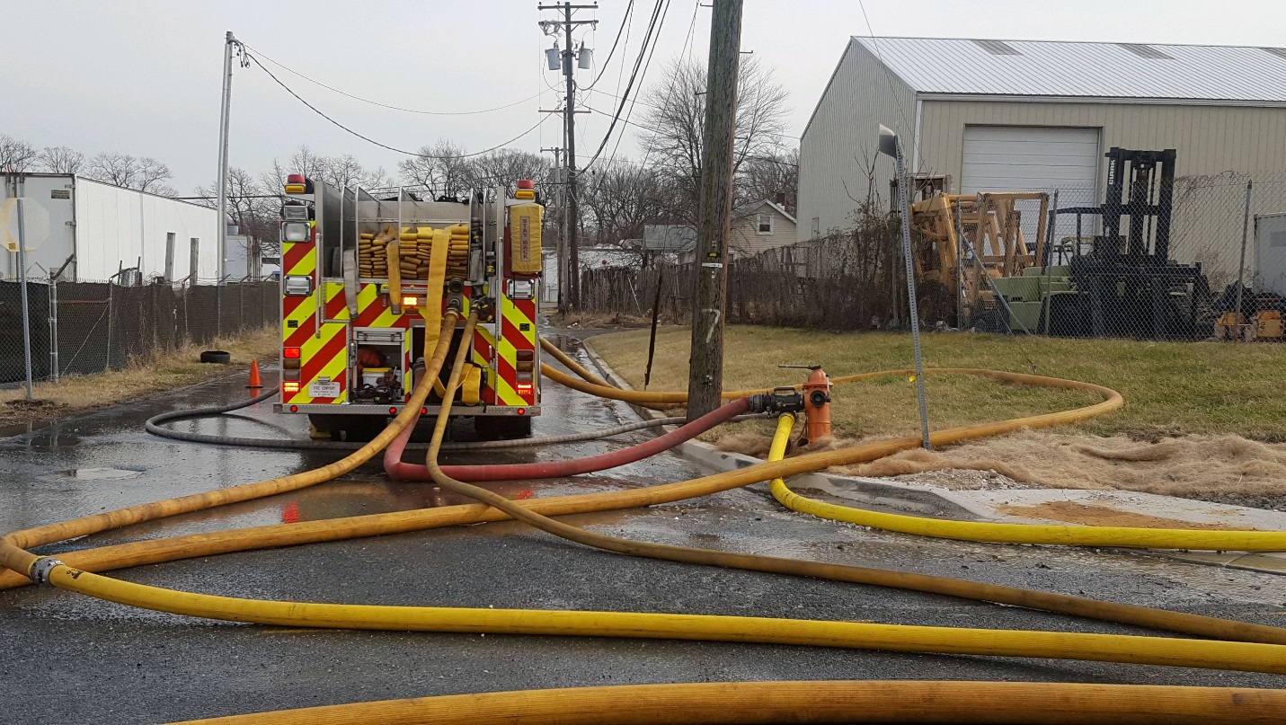

Baltimore County Fire Department
Fire - Rescue Academy

Published by:
Baltimore County Fire Rescue Academy
1545 Sparrows Point Boulevard
Sparrows Point, Maryland 21219
410-887-7523

Cover photos courtesy of Baltimore County Fire Department

Table of Contents
Checking Out the Pump/Engine 4
Checking the Pump at Shift Change 4
Nozzles/Tips & Appliances 8
Smoothbore Nozzles 8
Fog Nozzles/Constant Flow 9
Low Pressure Nozzle 10
Master Streams 11
Blitz Fire 13
Bresnan Distributor Nozzle 15
Tips & Appliances 16
Simplified Pump Charts 19
Friction Loss 25
Maximum Pressures / GPM 30
Relief Valve & Pressure Governors Procedures 31
Pressure Governors 36
Hydrants 37
Pumping the Hydrant 38
Heavy Water Hook-Up 40
Laying/Pumping Parallel – Dual Lines 42
Relay Pumping 45
Tandem Pumping 46
Dual Pumping 49
Drafting 55
Back Flushing the Pump 61
FOAM Educator/Midget 63
FDC Operations (Standpipe – Sprinkler) 66
Sprinkler Operations: 67
2” Hose High Rise Packs 69
How to Pack the High Rise Pack 71
Wyed Attack Lines 73
Pumping Multiple Lines 74
Pumping the Duce and A Half 2 ½” Attack Line 78
Knowing your nozzles: 79
Apartment Line “Horse Shoe” Load 82
How the Horse Shoe line is pulled / deployed: 83
2” Hose / Static Apartment Line 100’ of 2” 200’ of 2 ½“ 92
Ladder Pipe Operations 93

Checking Out the Pump/Engine

Checking the Pump at Shift Change
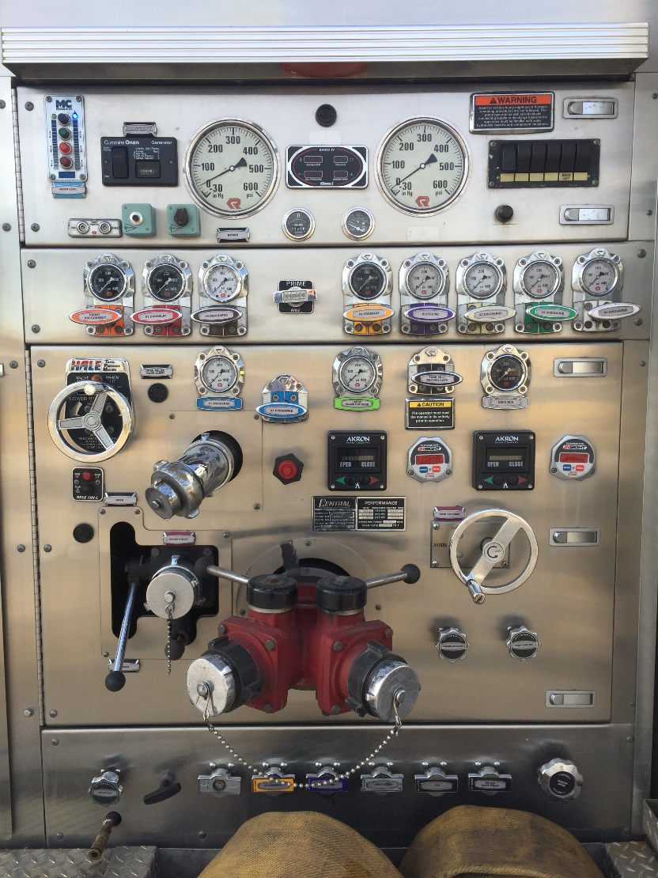

Step 1:
- Place Engine Transmission in “Neutral”
- Apply Parking Break
- Transfer Pump PTO into position
- Place Transmission in “Drive”
- Make sure the proper light, lights up advising engine is in Pump Gear or “OK to PUMP”

If the Engine has a switch for Pump Gear, DO NOT put Engine into Drive!

For the Engines that use a toggle-switch to go into Pump Gear:

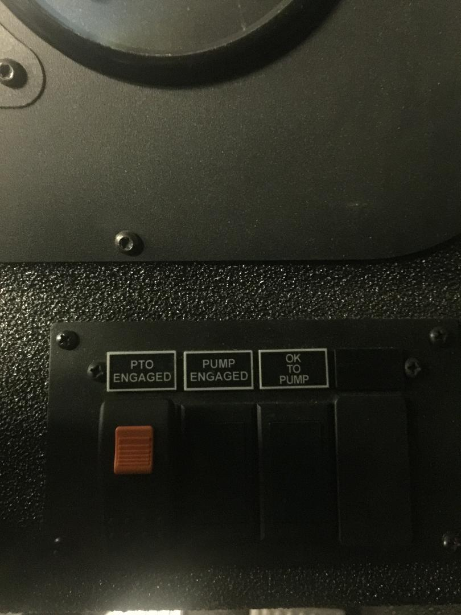

Located on the RIGHT side of the steering wheel, when sitting in the Driver’s Seat. DO NOT put the Engine in “DRIVE” when you flip the Toggle-switch to put the Engine into pump gear.

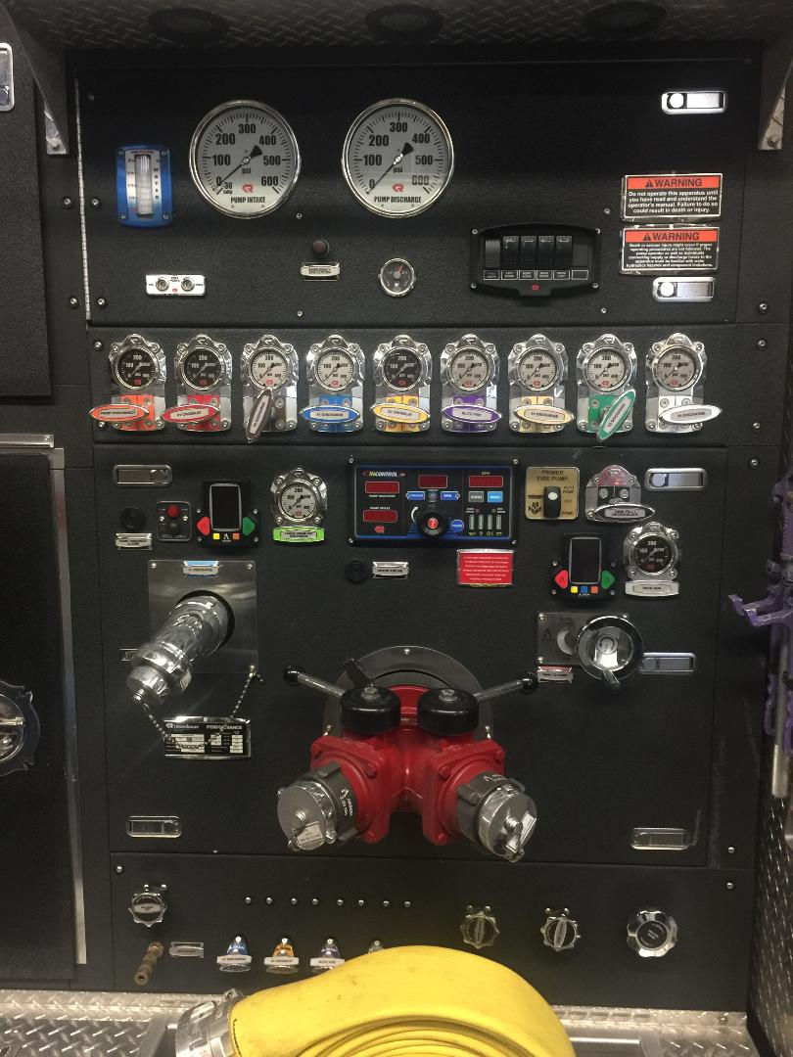

Pump Panel with a Pressure Governor vs. having a Relief Valve

Step 2:
- CHOCK YOUR TIRES!
- Drive Tires
- Pull TANK TO PUMP
- Set Relief Valve
- if it applies to your engine
- Throttle up – Making sure relief valve works, if your engine has one
- Audible alarm
- Visual light
- Check to make sure your PRIMER works
- RPM’s to be around 1200
- No more than 10-15 seconds while checking out the engine
- Check to make sure Tank has a full tank of Water
- Visual check
- Check to make sure tank fill level indicator lights work

Step 3: Do your walk around of the engine – checking Lights, Compartments, Tools, Medical Bags, Spare Bottles, Meters, Keys, Radios, Lights, Etc.

Step 4:
To take it out of Pump Gear
- Reverse all your steps (make sure everything at the Pump Panel is shut down)
- Take Transmission out of “Drive” and back into “Neutral”
- Take the Pump PTO out of Gear

OR

- Flip down the Toggle-switch, that put the Engine into Pump Gear

Nozzles/Tips & Appliances
Smoothbore Nozzles
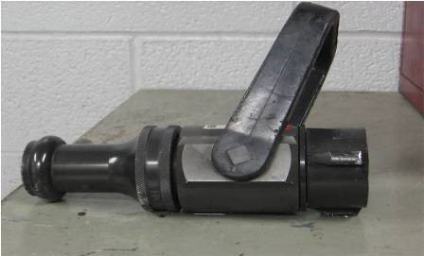
Nozzle Pressure – 50 psi
1 ¾” Line
Tips / GPM:

- 15/16” – 180 gpm

- 1” – 209 gpm

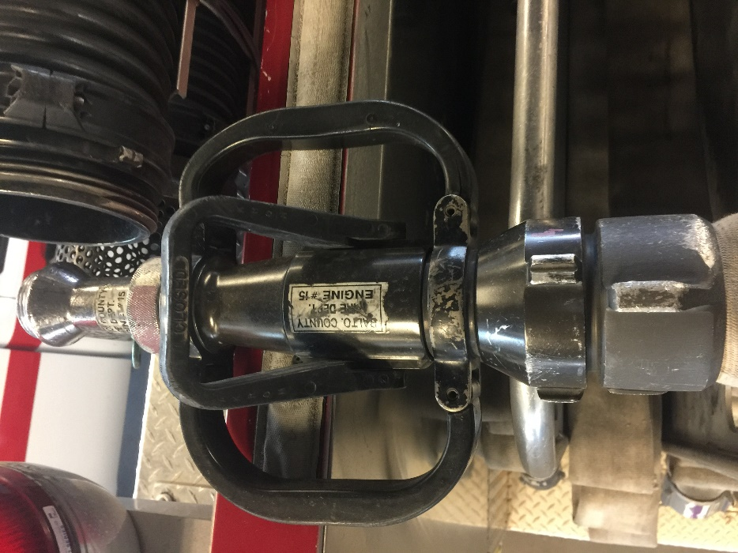
Nozzle Pressure – 50 psi
2 ½” Line
Tips / GPM:

- 1 1/8” – 265 gpm

- 1 ¼” – 326 gpm

Fog Nozzles/Constant Flow
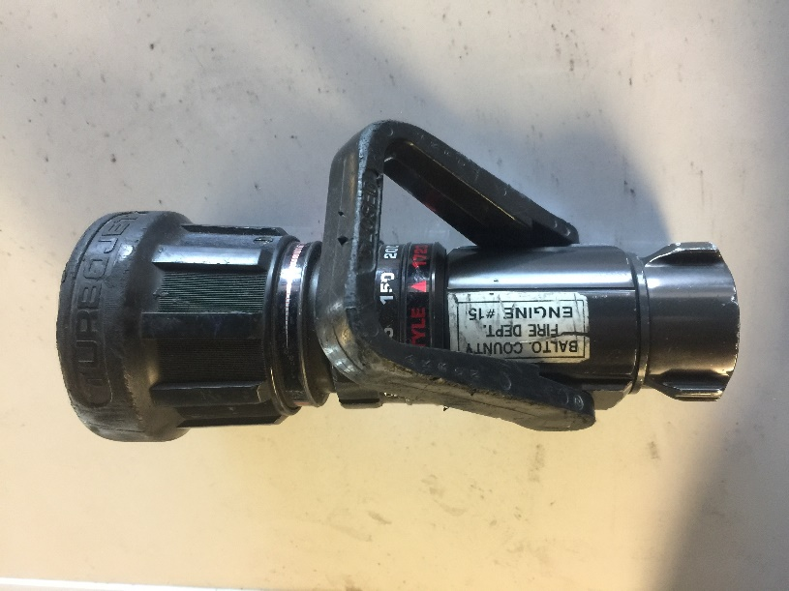
Settings / GPM
1 ¾” Line
- 95 gpm

- 150 gpm

- 200 gpm

Nozzle Pressure – 100 psi
Settings / GPM
2 ½” Line
- 125 gpm

- 150 gpm

- 200 gpm

- 250 gpm

Nozzle Pressure – 100 psi
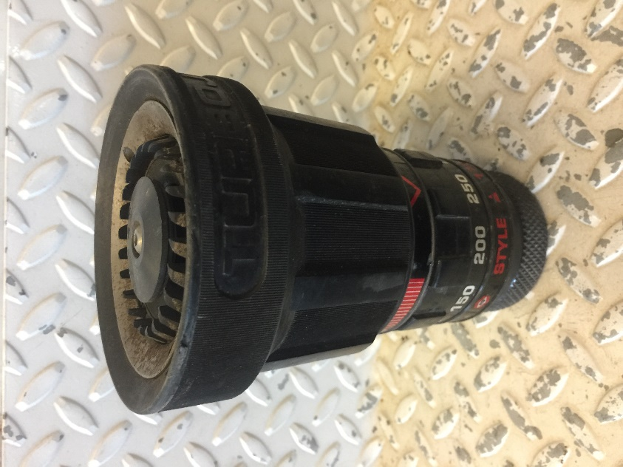

Low Pressure Nozzle
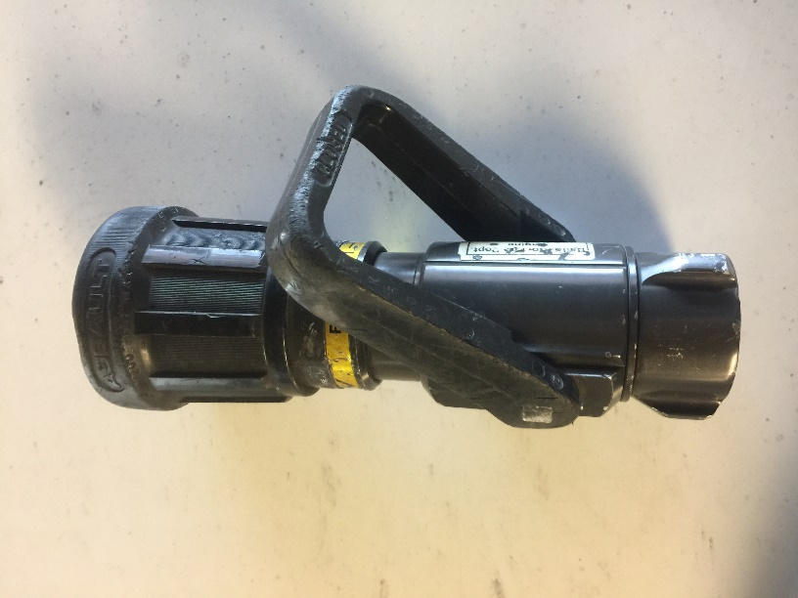
Setting / GPM
1 ¾” Line

200 gpm

@ 75 psi Nozzle Pressure

+ Friction Loss

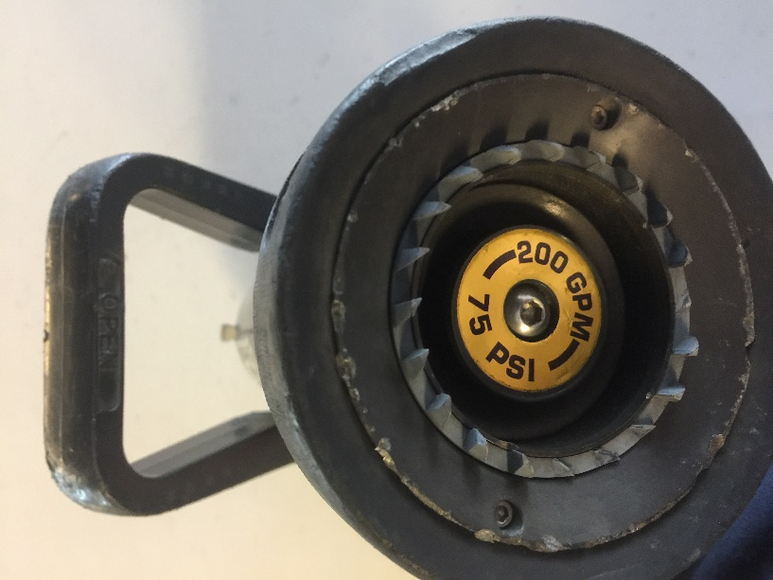

Master Streams
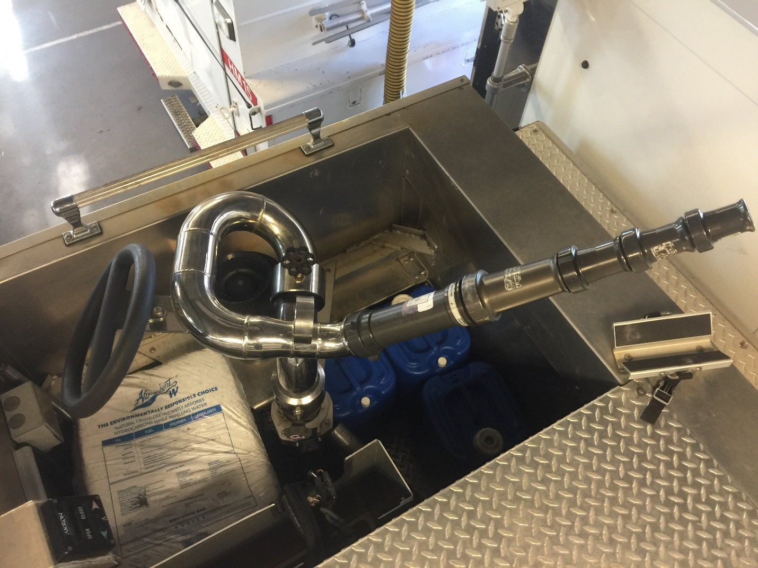
Stack Tip
@ 70 psi
- 1 3/8” – 469 gpm
- 1 ½” – 558 gpm
- 1 ¾” – 761 gpm
- 2” – 994 “1,000” gpm
@ 80 psi
- 1 3/8” – 500 gpm
- 1 ½” – 596 gpm
- 1 ¾” – 813 gpm
- 2” – 1,053 gpm

Add Friction Loss for Piping and Appliance

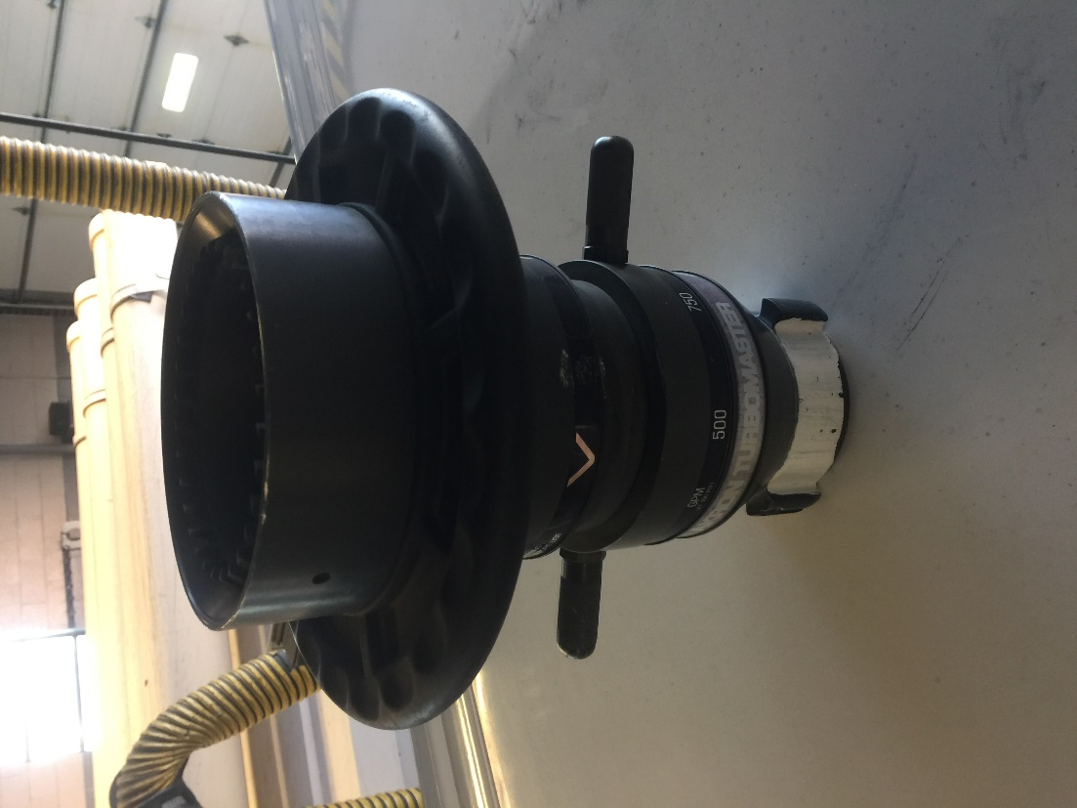

Fog Head Master Stream
Settings/GPM
100 psi for Nozzle Pressure
- 500 gpm
- 750 gpm
- 1000 gpm
- 1250 gpm

Blitz Fire
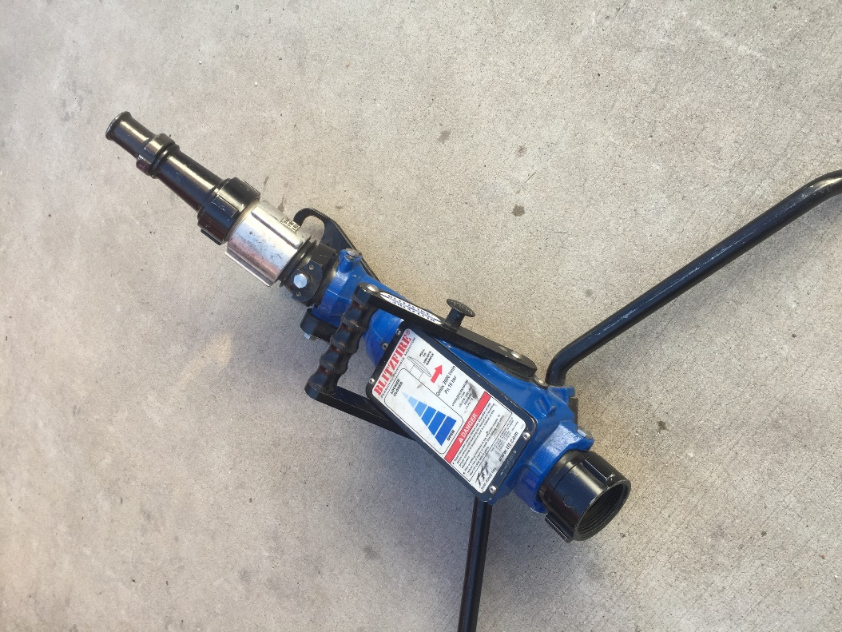
Connect to a 3” Line
Tips / GPM
@ 70 psi
- 1 ¼” – 388 gpm
- 1 3/8” – 470gpm
- 1 ½” – 559 gpm

+ Friction Loss
Tips / GPM
@ 80 psi
- 1 ¼” – 415 gpm
- 1 3/8” – 502gpm
- 1 ½” – 598 gpm

+ Friction Loss

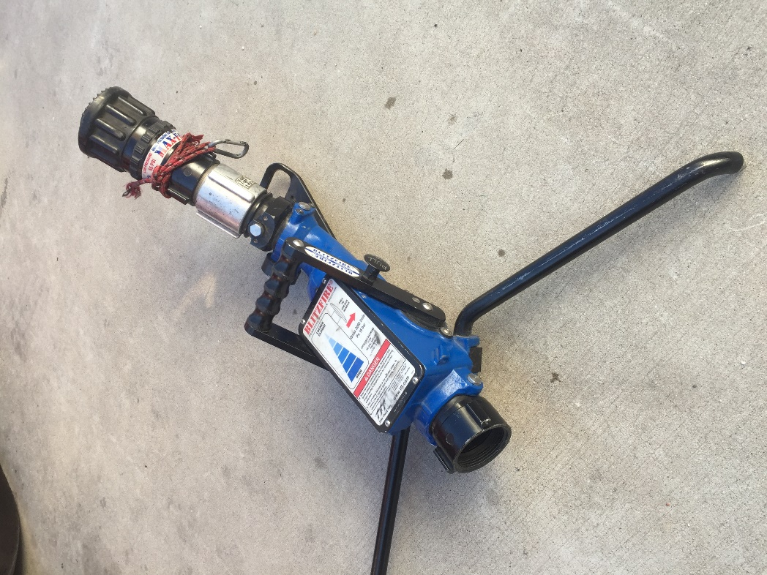
Connect to a 3” Line

Fog Head

100 – 500 gpm

@ 100 psi + Friction Loss

Bresnan Distributor Nozzle
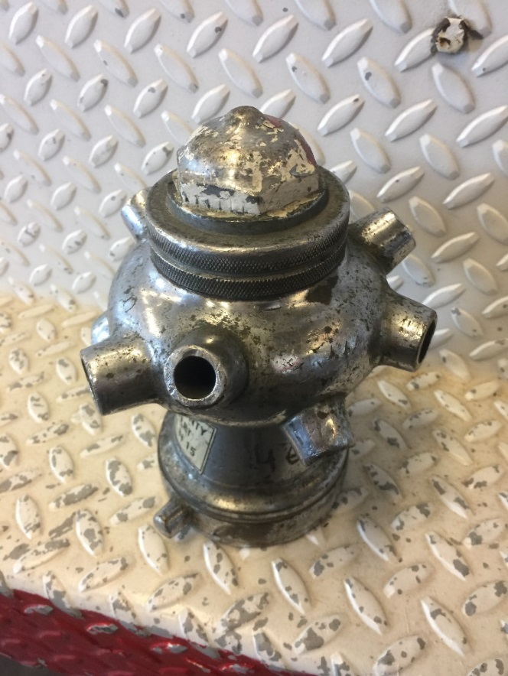

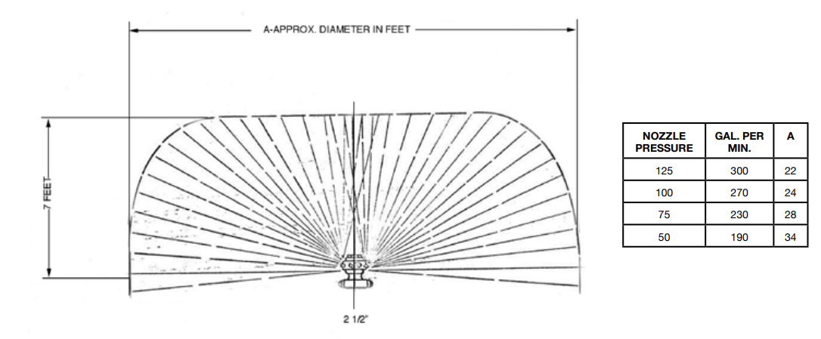

Tips & Appliances

Siamese:
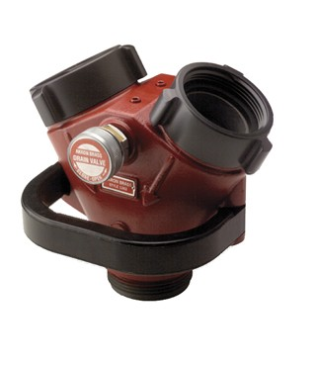

Thief:
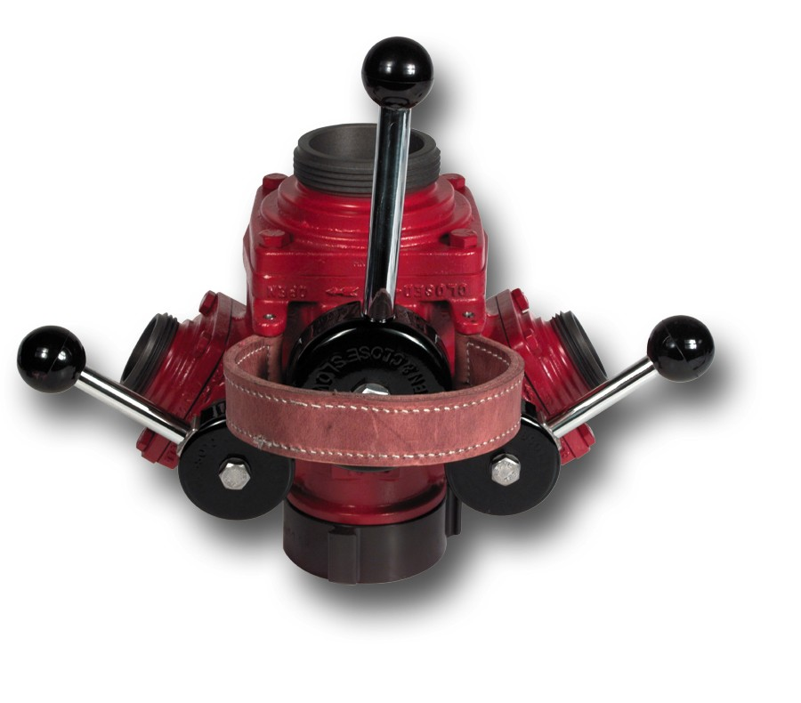

Gated Wye:
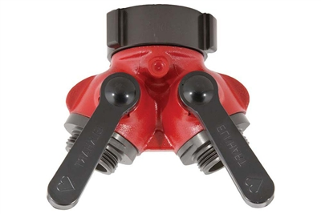

Ball Valve:
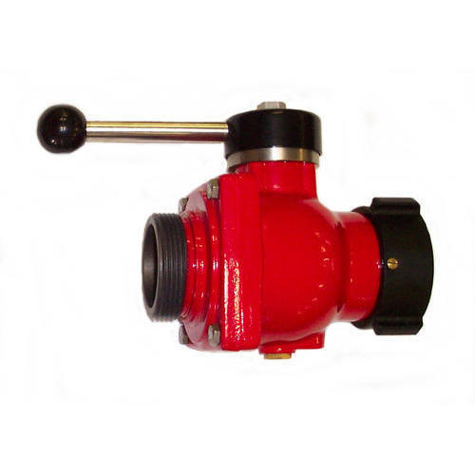

Piston Intake Valve:
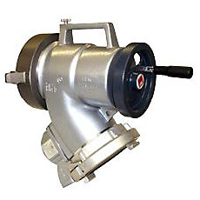

Simplified Pump Charts

“Horse Shoe / Static Line”
1 ¾” – 2 ½” - 1” tip – 210gpm
LENGTH | 50’ | 100’ | 150’ | 200’ | 250’ | 300’ | 350’ | 400’ | 450’
PSI | 80 | 110 | 140 | 144 | 148 | 152 | 156 | 160 | 164

“Horse Shoe / Static Line”
1 ¾” – 2 ½” – 15/16” tip – 180gpm
LENGTH | 50’ | 100’ | 150’ | 200’ | 250’ | 300’ | 350’ | 400’ | 450’
PSI | 75 | 100 | 125 | 128 | 131 | 134 | 137 | 140 | 143

1 ¾” Hand-line Smoothbore 1” tip – 210gpm
LENGTH | 50’ | 100’ | 150’ | 200’
PSI | 80 | 115 | 145 | 175

1 ¾” Hand-line Smoothbore 15/16” tip – 180gpm
LENGTH | 50’ | 100’ | 150’ | 200’
PSI | 75 | 100 | 125 | 150

1 ¾” Hand-line Constant Flow 150gpm
LENGTH | 50’ | 100’ | 150’ | 200’
PSI | 120 | 135 | 150 | 170

1 ¾” Hand-line Low Pressure Nozzle 200gpm – 75psi NP
LENGTH | 50’ | 100’ | 150’ | 200’
PSI | 105 | 135 | 165 | 195

2 ½” Hand-line
1 1/8” tip – 265gpm / 50psi NP
LENGTH | 50’ | 100’ | 150’ | 200’ | 250’
PSI | 57 | 64 | 71 | 78 | 85

2 ½” Hand-line
1 ¼” tip – 326gpm / 50psi NP
LENGTH | 50’ | 100’ | 150’ | 200’ | 250’
PSI | 60 | 70 | 80 | 90 | 100

Static Line / Apartment Line
100’ of 2”
200’ of 2 ½”
1” tip – 210gpm
LENGTH | 100’ | 150’ | 200’ | 250’ | 300’
PSI | 72 | 76 | 80 | 84 | 88

Static Line / Apartment Line
100’ of 2”
200’ of 2 ½”
1 1/8” tip – 265gpm
LENGTH | 100’ | 150’ | 200’ | 250’ | 300’
PSI | 82 | 89 | 96 | 103 | 110

Static Line / Apartment Line
100’ of 2”
200’ of 2 ½”
1 ¼” tip – 326gpm
LENGTH | 100’ | 150’ | 200’ | 250’ | 300’
PSI | 95 | 105 | 116 | 126 | 137

SIMPLIFIED PRESSURE CHART
1 ¾” to 2 ½” STATIC LINE
1” TIP 209gpm

LENGTH | 50 | 100 | 150 | 200 | 250 | 300 | 350 | 400 | 450
PSI | 80 | 110 | 140 | 144 | 148 | 152 | 156 | 160 | 164

1 ¾” SMOOTH-BORE LINE
15/16” TIP 180gpm
LENGTH | 50ft | 100ft | 150ft | 200ft
PSI | 75 | 100 | 125 | 150

1 ¾” SMOOTH-BORE LINE
1” TIP 209gpm
LENGTH | 50ft | 100ft | 150ft | 200ft
PSI | 80 | 110 | 140 | 170

1 ¾” CONSTANT FLOW
150gpm Setting
LENGTH | 50ft | 100ft | 150ft | 200ft
PSI | 120 | 135 | 150 | 170

2 ½” BLITZ LINE
1 1/8” 265gpm / 1 1/4" 326gpm
LENGTH | 50ft | 100ft | 150ft | 200ft | 250ft
1 1/8” | 57 | 64 | 71 | 78 | 85
1 1/4” | 61 | 72 | 82 | 93 | 104

Deck-Gun
Tip: | 1 3/8” | 1 ½” | 1 ¾” | 2”
70psi | 470gpm | 559gpm | 761gpm | 994gpm
80psi | 502gpm | 598gpm | 814gpm | 1063gpm
100psi | 560gpm | 667gpm | 909gpm | 1189gpm

1 ¾” Friction Loss
95gpm per 100’ 14FL / per 50’ 7
150gpm per 100’ 35FL / per 50’ 15FL
180gpm per 100’ 50FL / per 50’ 25FL
200gpm per 100’ 60FL / per 50’ 30FL
2 ½” Friction Loss
180gpm per 100’ 6FL / per 50’ 3FL
200gpm per 100’ 8FL / per 50’ 8FL
210gpm per 100’ 9FL / per 50’ 5FL
250gpm per 100’ 13FL / per 50’ 6FL
265gpm per 100’ 14FL / per 50 7FL
326gpm per 100’ 20FL / per 50’ 10FL
2” Friction Loss
180gpm per 100’ 16FL / per 50’8FL
200gpm per 100’ 20FL / per 50’ 10FL
210gpm per 100’ 22FL / per 50’ 11FL
265gpm per 100’ 14FL / per 50’ 7FL

BLITZFIRE STACK TIP PUMP CHART
1 ¼” TIP
PRESSURE |  | FLOW
PSI | GPM
40 | 294
50 | 328
60 | 360
70 | 388
80 | 415
90 | 440
100 | 464
110 | 487

1” TIP
PRESSURE |  | FLOW
PSI | GPM
40 | 188
50 | 210
60 | 230
70 | 249
80 | 266
90 | 282
100 | 297
110 | 312

1 ½” TIP
PRESSURE |  | FLOW
PSI | GPM
40 | 423
50 | 473
60 | 518
70 | 559
80 | 598
90 | 634
100 | 668
110 | 701
FRICTION LOSS PER 100 FEET, 2 ½” AND 3”
GPM | 2 ½” | 3”
200 | 8 | 3
220 | 10 | 4
250 | 13 | 5
260 | 14 | 5
280 | 16 | 6
300 | 18 | 7
320 | 20 | 8
340 | 23 | 9
360 | 26 | 10
380 | 29 | 12
400 | 32 | 13
425 | 36 | 14
450 | 40 | 16
475 | 45 | 18
500 | 50 | 20
525 |  | 22
550 |  | 24
575 |  | 26
600 |  | 29
625 |  | 31
650 |  | 34
675 |  | 36
700 |  | 39

BLITZFIRE PUMP CHART
3” SUPPLY, PUMP DISCHARGE PRESSURE
FLOW | 150FT |  | 200FT |  | 250FT |  | 300FT |  | 350FT |  | 400FT
150gpm | 100 | 50 | 105 | 50 | 105 | 50 | 105 | 50 | 105 | 50 | 105 | 50
200gpm | 110 | 55 | 115 | 55 | 115 | 55 | 115 | 60 | 120 | 60 | 120 | 60
250gpm | 115 | 60 | 120 | 65 | 120 | 65 | 125 | 70 | 125 | 70 | 130 | 75
300gpm | 120 | 70 | 125 | 70 | 130 | 75 | 130 | 80 | 135 | 85 | 140 | 85
350gpm | 125 | 80 | 130 | 85 | 135 | 90 | 140 | 95 | 145 | 100 | 150 | 105
400gpm | 130 | 100 | 135 | 105 | 145 | 110 | 150 | 115 | 155 | 125 | 160 | 130
450gpm | 135 | 125 | 145 | 135 | 155 | 140 | 160 | 150 | 170 | 160 | 180 | 165
500gpm | 155 | 155 | 165 | 165 | 175 | 175 | 185 | 185 | 195 | 195 | 205 | 205
Standard Pressure Low Pressure

AVAILABLE WATER FROM HYDRANTS
0-10% 3X FLOW 11-15 2X FLOW 16-25 1X FLOW +25% >FLOW
RESIDUAL | STATIC
 | PSI | 100 | 95 | 90 | 85 | 80 | 75 | 70 | 65 | 60 | 55 | 50
 | 80 | 1 | 2 | 2 | 3 | 3+
 | 75 | 1 | 1 | 1 | 2 | 3 | 3+
 | 70 | 0 | 0 | 1 | 2 | 2 | 3 | 3+
 | 65 | 0 | 0 | 0 | 1 | 1 | 2 | 3 | 3+
 | 60 | 0 | 0 | 0 | 0 | 1 | 1 | 2 | 3 | 3+
 | 55 | 0 | 0 | 0 | 0 | 0 | 0 | 1 | 2 | 3 | 3+
 | 50 | 0 | 0 | 0 | 0 | 0 | 0 | 0 | 1 | 1 | 3 | 3+
 | 45 | 0 | 0 | 0 | 0 | 0 | 0 | 0 | 0 | 1 | 1 | 3
 | 40 | 0 | 0 | 0 | 0 | 0 | 0 | 0 | 0 | 0 | 0 | 1

Friction Loss

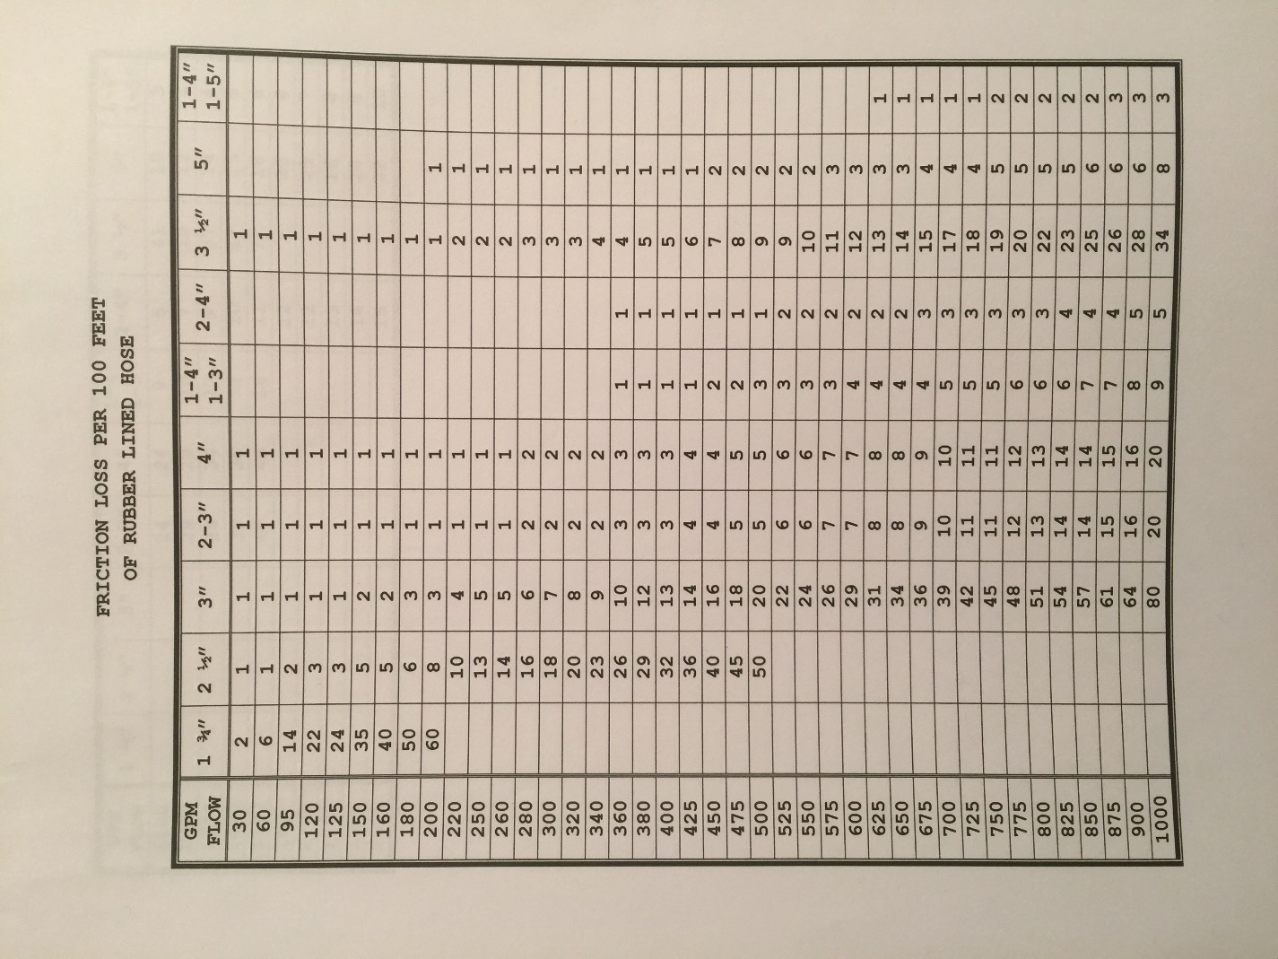

DISCHARGE OF SMOOTH BORE NOZZLES – GPM
Pressure | 15/16” | 1” | 1 1/8” | 1 1/4" | 1 3/8” | 1 1/2" | 1 3/4" | 2”
50 | 185 | 209 | 265 | 326 | 396 | 472 | 643 | 841
60 | 202 | 229 | 290 | 357 | 434 | 517 | 704 | 920
70 | 218 | 247 | 313 | 386 | 469 | 558 | 761 | 994
80 | 234 | 264 | 335 | 413 | 500 | 596 | 813 | 1053
90 | 248 | 280 | 355 | 438 | 531 | 633 | 862 | 1128
100 | 261 | 295 | 374 | 461 | 560 | 667 | 909 | 1189

DECK GUN FLOW CHART
Maintain 100psi
(80psi nozzle, 20psi friction loss)
TIP | 1 3/8” | 1 ½” | 1 ¾” | 2”
FLOW | 500gpm | 596gpm | 813gpm | 1053gpm

BLITZFIRE PUMP CHART

AUTOMATIC FOG
3” SUPPLY, PUMP DISCHARGE PRESSURE
FLOW | 150FT |  | 200FT |  | 250FT |  | 300FT |  | 350FT |  | 400FT
150gpm | 100 | 50 | 105 | 50 | 105 | 50 | 105 | 50 | 105 | 50 | 105 | 50
200gpm | 110 | 55 | 115 | 55 | 115 | 55 | 115 | 60 | 120 | 60 | 120 | 60
250gpm | 115 | 60 | 120 | 65 | 120 | 65 | 125 | 70 | 125 | 70 | 130 | 75
300gpm | 120 | 70 | 125 | 70 | 130 | 75 | 130 | 80 | 135 | 85 | 140 | 85
350gpm | 125 | 80 | 130 | 85 | 135 | 90 | 140 | 95 | 145 | 100 | 150 | 105
400gpm | 130 | 100 | 135 | 105 | 145 | 110 | 150 | 115 | 155 | 125 | 160 | 130
450gpm | 135 | 125 | 145 | 135 | 155 | 140 | 160 | 150 | 170 | 160 | 180 | 165
500gpm | 155 | 155 | 165 | 165 | 175 | 175 | 185 | 185 | 195 | 195 | 205 | 205

Remember This
(Quick Reference to knowing GPM/FL)

- @ 95gpm 1 ¾” – 14FL per 100’
- @ 150gpm 1 ¾” – 35FL per 100’
- @ 180gpm 1 ¾” – 50FL per 100’
- @ 200gpm 1 ¾” – 60FL per 100’

- @ 265gpm 2 ½” – 14FL per 100’
- @ 326gpm 2 ½” – 20FL per 100’

Maximum Pressures / GPM

Hose Sizes – Max Pressures – Max GPM

- 1 ¾” Max Pressure – 200psi / Max GPM – 200gpm

- 2 ½” Max Pressure – 200psi / Max GPM – 326gpm

- 3” Max Pressure – 200spi / Max GPM – 500gpm

- 4” Max Pressure – 180psi (per SOP) / Max GPM – 1,000

- 5” Max Pressure – 180psi (per SOP) / Max GPM – 1,200

Relief Valve & Pressure Governors Procedures

Hale TPM – Relief Valve

What does TPM mean?
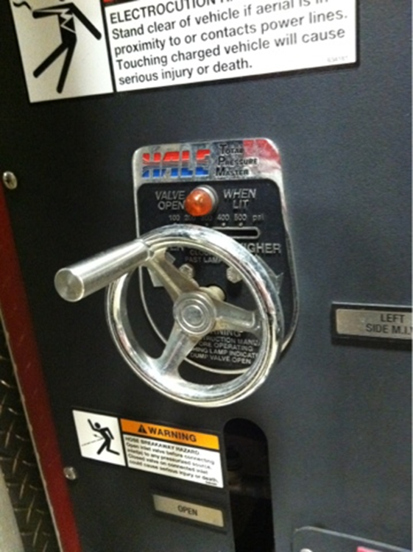
Total Pressure Master Relief Valve

How it works….

- Set the pressure control valve to a position slightly above the “Indicated” operating pressure (even before water starts to flow)

- After normal operating pressure has been achieved (as indicated on the Master Pressure Gauge, while the pump is discharging water), slowly move the adjustable hand wheel counterclockwise, until the relief valve opens. Amber light indicator should come on

- Turn the hand wheel slowly clockwise now, until the indicator light goes off. The relief valve will operate at the set pressure
INCONTROL Pressure Governor TGA-400

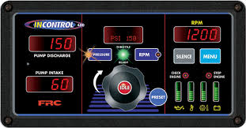

Procedures:
- Pressure Mode
- RPM Mode
- Switching Between Operating Modes

Pressure Mode Operation
In the pressure mode of operation the PRESSURE LED is on. The governor maintains a constant discharge pressure within system capabilities. It adjusts the engine RPM automatically to compensate for variations in pressure.
There is a maximum engine RPM programmed in the governor for pressure mode. If the engine reaches the programmed maximum RPM the message display flashes MAX RPM / OPERATOR and the engine RPM is not allowed to go higher. (The maximum engine RPM is normally set at 2100 and is programmable.)
If the discharge pressure is below 15 PSI when the operator increases the pressure setting, the display shows PRESS LOW.
Note: When changing from RPM to pressure mode during operations, hold the PRESSURE button for 3 seconds. The pressure setting is the pressure that the pump was operating at in RPM mode.
1. Press PRESSURE button to select the pressure mode.
Result: PRESSURE LED goes on.
2. Press PRESET and/or INC/DEC or rotate the control knob to select pressure setting.
Result: Message display shows pressure setting, engine RPM changes.
3. Press IDLE button after operations to bring engine to idle RPM.
Result: Message display shows IDLE ENGINE, engine at idle RPM.
Opening/Closing Discharge Valves
In pressure mode the governor maintains the pressure setting regardless of the number of discharge lines that are opened or closed providing there is sufficient water supplied. As lines are opened the discharge pressure starts to drop, and the governor raises the engine RPM to maintain the required pressure. As lines are closed and the discharge pressure starts to rise, the governor lowers the engine RPM to maintain the required pressure.
Operating From a Pressurized Supply
When operating from a pressurized water source (hydrant, in-relay, etc.), the intake supply should be routed through a valve. If the pressurized source fails, the pump operator can close the valve. This eliminates the chance of sharp pressure spikes at the pump intake if the supply is resumed suddenly. The operator must open this valve slowly when the supply is resumed to help prevent pressure spikes.

RPM Mode Operation
In the RPM mode of operation the RPM LED is on. The governor maintains a constant engine RPM.
The pump discharge pressure can vary but, as a safety feature, the governor limits the increase in pressure to 30 PSI over the last established PSI value. As the discharge pressure approaches this limit the governor automatically lowers the RPM to prevent a high pressure surge. The RPM LED blinks as the governor sets a lower RPM. This lower RPM will be the new operating RPM setting.
Note: When changing from pressure to RPM mode during operations, hold the RPM button for 3 seconds. The RPM setting is the RPM that the pump was operating at in pressure mode.
1. Press RPM button to select RPM mode.
Result: RPM LED goes on.
2. Press PRESET and/or INC/DEC or rotate the control knob to select RPM setting.
Result: Message display shows RPM setting, engine RPM changes.
3. Press IDLE button after operations to bring engine to idle RPM.
Result: Message display shows IDLE ENGINE, engine at idle RPM.

Switching Between Operating Modes
• No variation in discharge pressure or RPM occurs when changing between pressure and RPM modes.
• When changing to RPM mode, the RPM setting is the RPM that the pump was operating at in pressure mode.
• When changing to pressure mode the pressure setting is the pressure that the pump was operating at in RPM mode.
When the engine is at idle RPM:
Press PRESSURE or RPM button, governor changes modes immediately.
When the engine RPM is above idle:
Press and hold PRESSURE or RPM button for 3 seconds, governor changes modes. (This is to avoid an accidental change over if the buttons get bumped.)
Pump Discharge Pressure is High at Engine Idle
Once the governor has set the engine RPM at idle, it can do no more to reduce discharge pressures. To reduce discharge pressure the pump operator can gate incoming water, reduce pressure at the intake relief valve, gate discharges, or disable the pump.
RPM Limit with Discharge Pressure Less than 100 PSI
The level II programming code P221 sets the maximum RPM when the pump is operating with a discharge pressure less than 100 PSI.

Pressure Governors
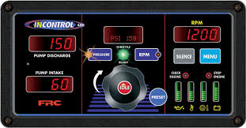
The Fire research INControl pressure governor and all-in-one instrument panel uses state of the art programmable microprocessor technology. Measuring only 10.5 by 5.5 inches the INControl offers pump discharge and pump intake displays, pump pressure or RPM control, and remote engine displays. It will maintain a steady pump discharge pressure by controlling engine speed or hold a selected engine RPM. It offers complete engine control and remote display in a single compact unit.
The INControl operates in one of two modes, pressure or RPM. In pressure mode the INControl maintains a constant pump discharge pressure. The discharge pressure is monitored and compared to the selected pressure setting, the engine RPM is varied to keep the discharge pressure at the selected setting. In RPM mode the INControl maintains a constant engine RPM. The pump discharge pressure is monitored and can vary but, as a safety feature it will be limited to an increase of 30 PSI. If the discharge pressure increases 30 PSI the governor will automatically lower the engine RPM to prevent a high pressure surge.
The TGA400 Series uses the FRC hand throttle style control knob to adjust pressure and RPM settings.
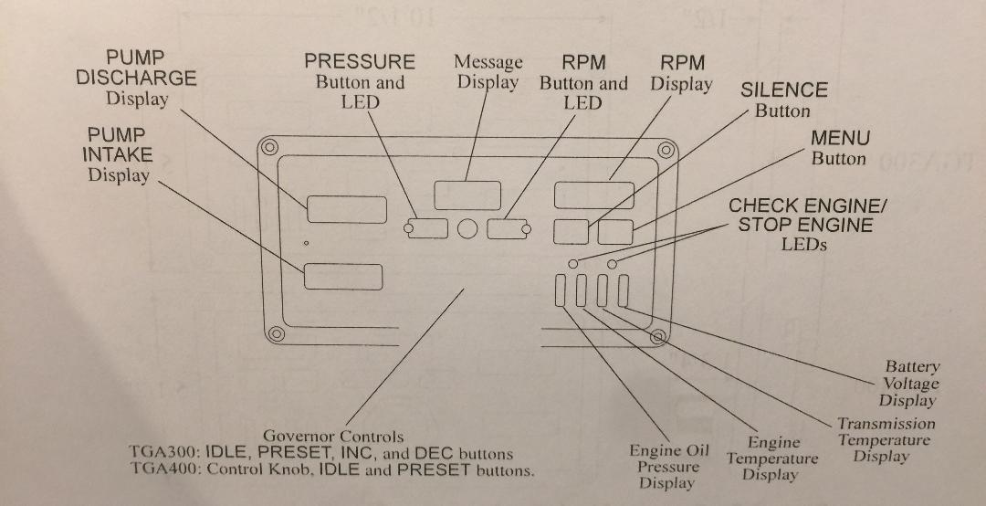

Hydrants

As a driver (FADO / Back-up Driver) do you know the type of Fire Hydrants we have and how they operate?
(Dry Barrel)
Types of Hydrants:
- Muller
- A.P. Smith
- American Darling
- Other

Parts of the Hydrant:
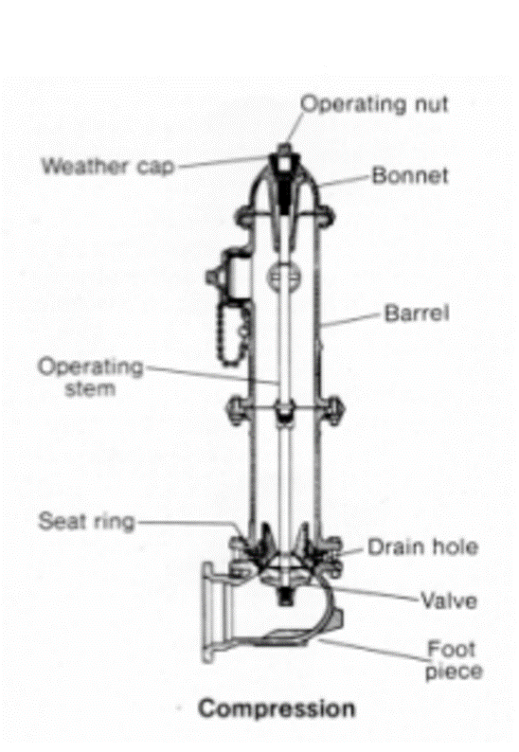

Note: Baltimore County & City operate with the same threads (Baltimore Steamer). If you run outside of these two jurisdictions, you may need to use the National Standard Thread (NST) Adapter. This is to be placed on the hydrants front 4 ½” thread and then you can connect you appliance/Humat to the NST.

Pumping the Hydrant

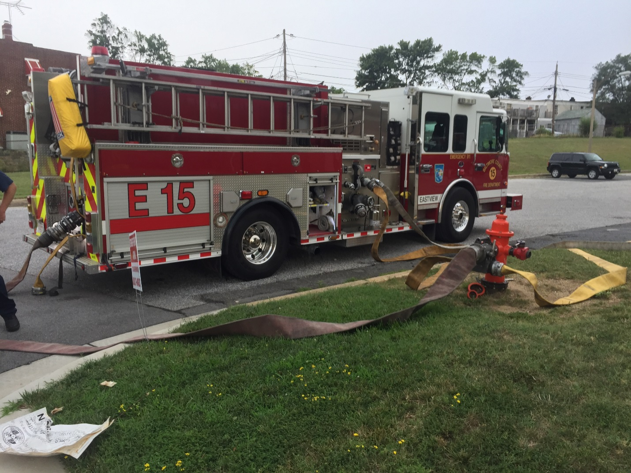

You are the Second Due Engine, you arrive on the hydrant that the first engine laid in from.

What will you need?
- HUMAT
- Ball Valve(s)
- Soft Sleeve
- Short shot of 4in hose

What do you need to do?
- Pulling up, you will need to position the engine appropriately near the hydrant, whether you are using your side intake or rear intake
- Place engine in Pump Gear
- Chock your tires
- If not Done so already, Hook-up the humat to the hydrant
- Try to at least get a Ball Valve on one of the 2 ½” side threads
- Listen for or Ask when to charge the supply Line
- Hook-up soft sleeve from the exposed threads on the humat, take the other side with the storz fitting, to either your side or rear intake, Open Intake
- Use a short shot of 4in hose from your LDH DISCHARGE to the side of the Humat (opposite side of there the LDH hose is already). This is for Boosting Pressure
- Open humat valve, allowing the soft sleeve to be charged and water to into your intake
- Notice Static Pressure
- Charge your LDH Discharge
- 50psi to start
- Add Friction Loss on top of the 50psi
- Need to know the Fire Flow – Total GPM’s being used, to determine Friction Loss for the supply line
- Crack tank fill
- Communicate with the other driver to maintain water and pressures

Heavy Water Hook-Up

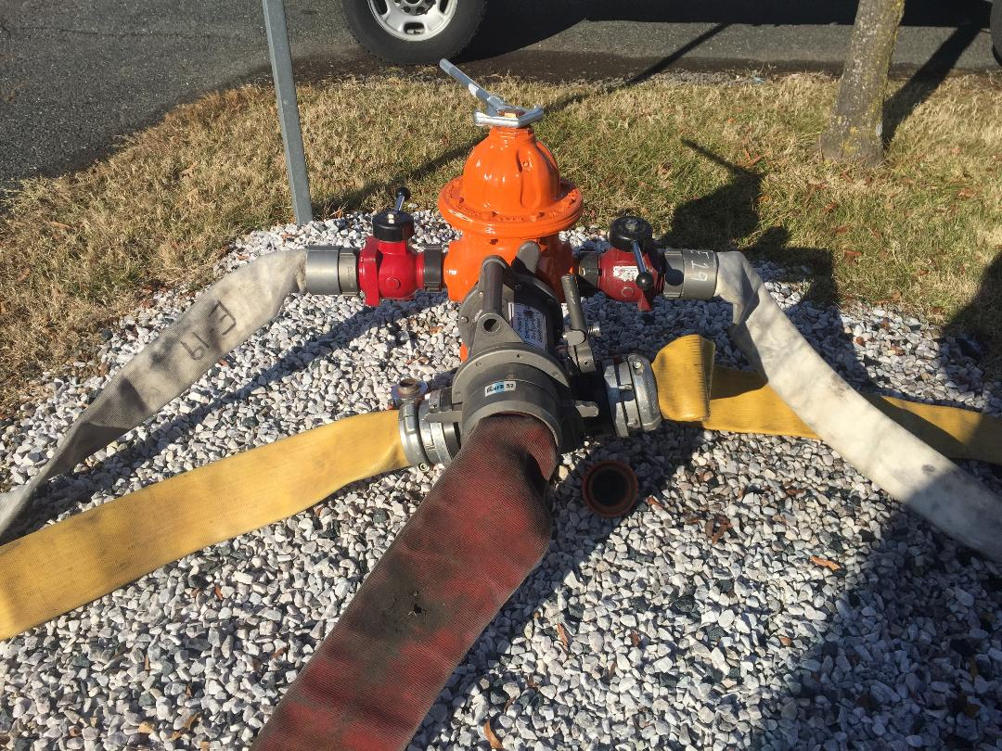
To maximize your Hydrant to get the most maximum available water

This is the same process as you would do for Pumping the Hydrant, but adding a few other steps

What do you need?
- Two Ball Valves
- Sufficient sections of 3in hose
What do I need to do?
- Put a Ball Valve on each side of the hydrant on the 2 ½” threads
- Take sufficient length(s) of 3in hose from one Ball Valve to your Steamer fitting on the pump panel or to a direct tank fill
- Do the same with the other sufficient length(s) of 3in hose from the other Ball Valve on the hydrant
Charge the hydrant when all set up, then charge each Ball Valve line slowly
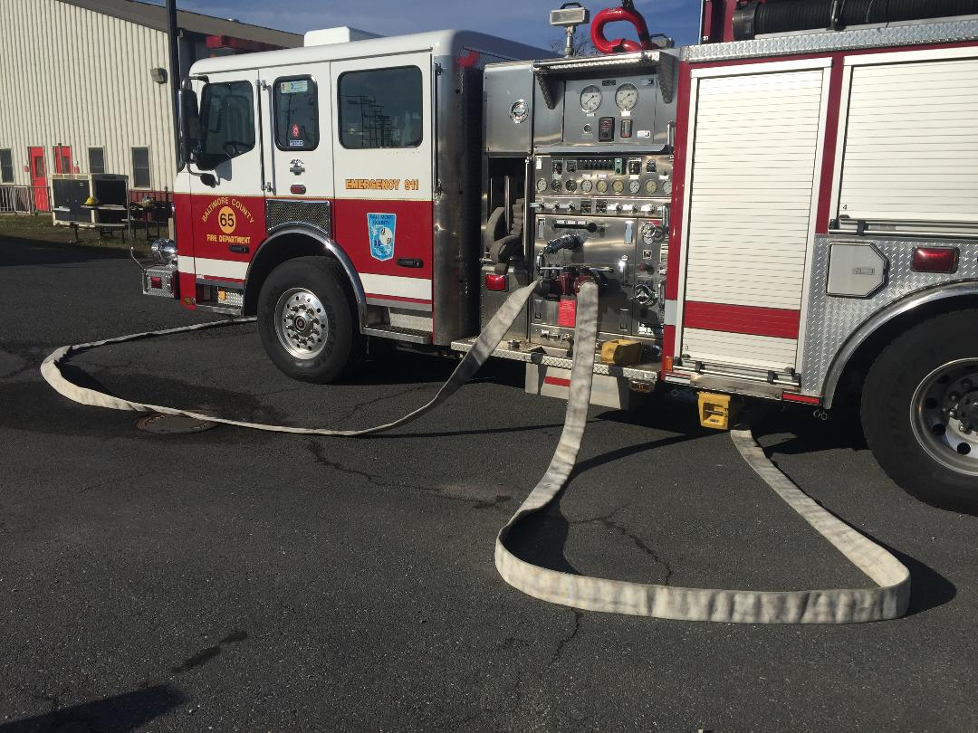

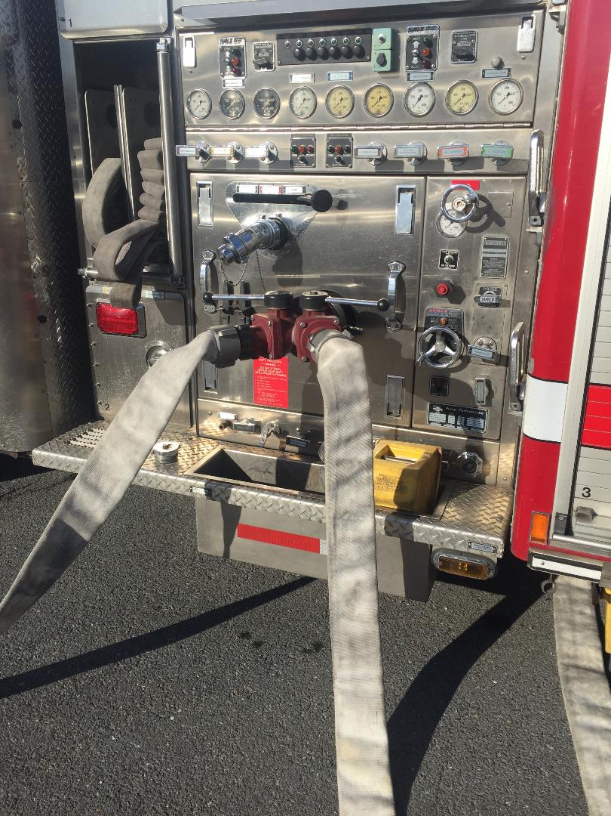

Laying/Pumping Parallel – Dual Lines

Purpose:
Laying dual lines is not commonly seen anymore these days, unless you know arriving that you have a big fire where you’ll need big water! The reason dual lines were laid back in the day, was because engine companies did not carry the LDH hose we do today. Engine companies carried 3 inch as their supply lines. By laying dual 3 inch lines back then, that got the engine sufficient water from the hydrant. Today, there are still fires where we lay dual lines, and need that extra water. If we lay dual lines today, it is usual a 3 inch line, along with our LDH supply line. Some engine companies are set up so that they can drop a split lay of two LDH lines.

Things to consider:
- You need to determine if you are the engine company that is laying dual lines; what size lines you are laying, understand how much hose you have (length wise for each), and think about your water source.
- Determine if you are the engine company that is going to be pumping the dual line, and how you will be doing that

Putting it all together:
It follows the same process as pumping the hydrant, and heavy water hook up. You will need the same things, but will need to add a Siamese to one of the Ball Valves.

Example:
Engine 6 arrived with a known working fire, and determined they need every bit of water they can get from the hydrant. Engine 6 laid dual lines consisting of 4 inch LDH and 3 inch hose. The total length of hose laid for each is 500 feet.
Now, you’re arriving as the second due engine (Engine 15), you have to hook all this up, and give Engine 6 water and the correct pressures.
How do you do this? Well, just like pumping the hydrant and heavy water hook up. You need to add a Siamese to one of your Ball Valves.
Once you get everything set up, determine when you can charge the hydrant to get Engine 6 some water in their 4in line, then boost their pressure.
Take Engine 6’s 3in line that they dropped, and connect the female end to the male end of the Siamese. Take a 3in line from one of your discharges and connect it to the female fitting on the Siamese, too boost the pressure on the 3in line going to Engine 6. Take a 3 in line from you other Ball Valve on the hydrant, and hook up to your steamer fitting on the pump panel or into a direct tank fill.
To determine the proper Pump Pressures for each line, communicate with the driver of Engine 6 and get the fire flow. Once you know how many GPM’s they are flowing, you can then figure out the Friction Loss for each size line based off the fire flow.

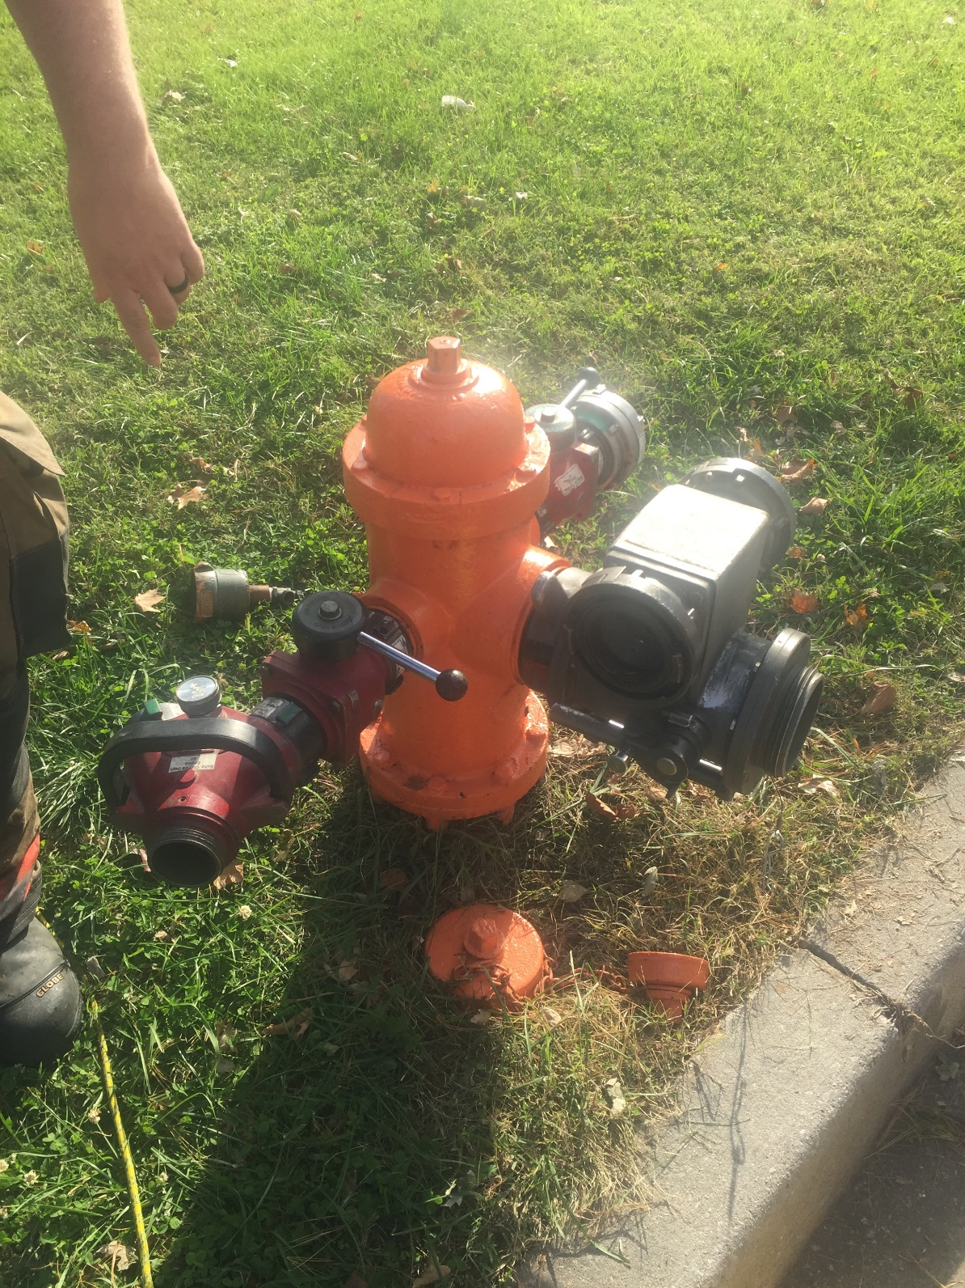

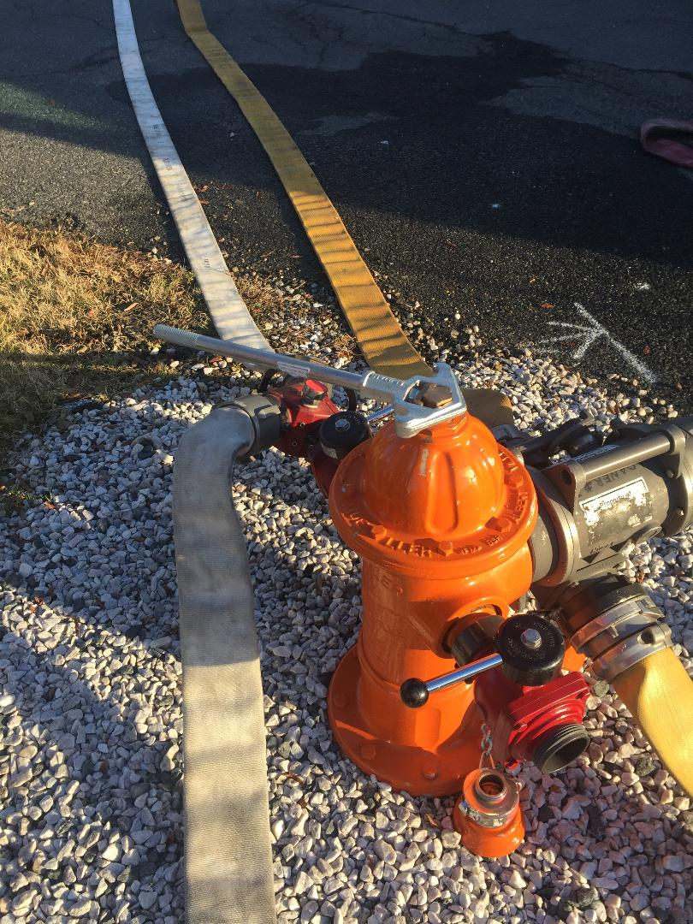
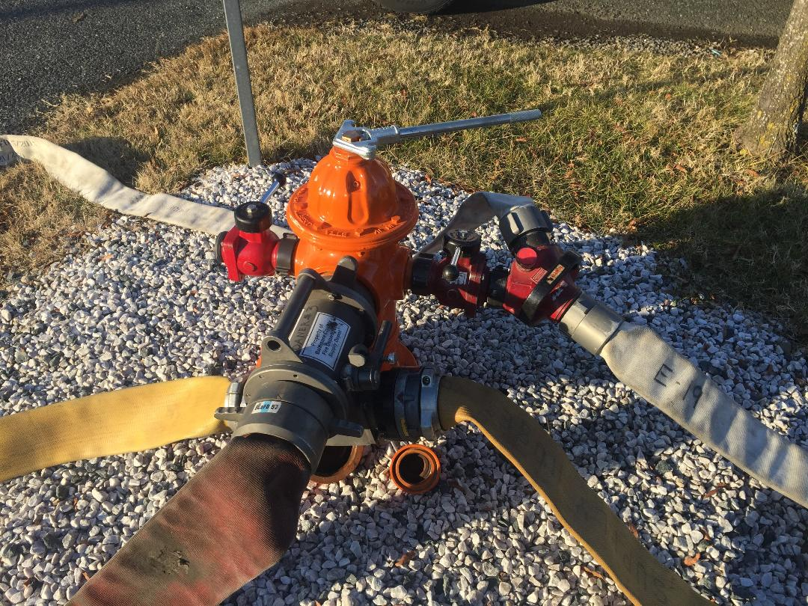

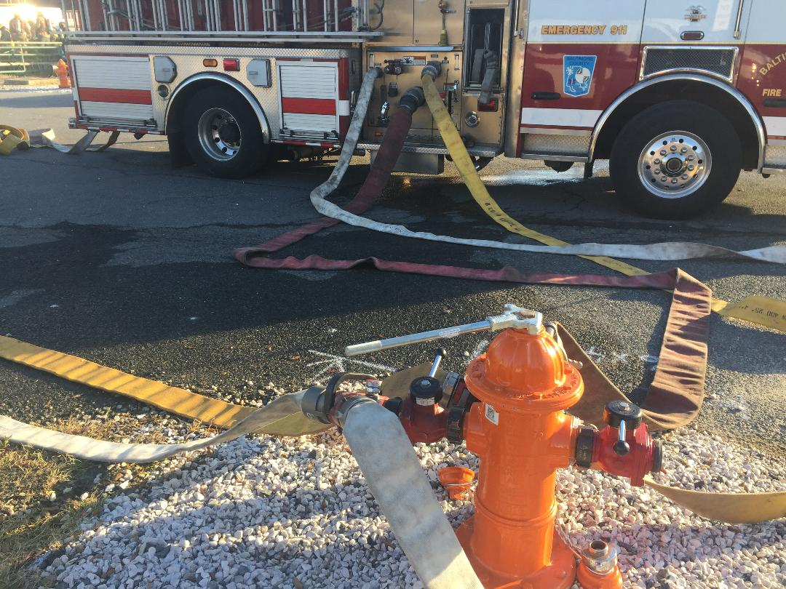

Relay Pumping

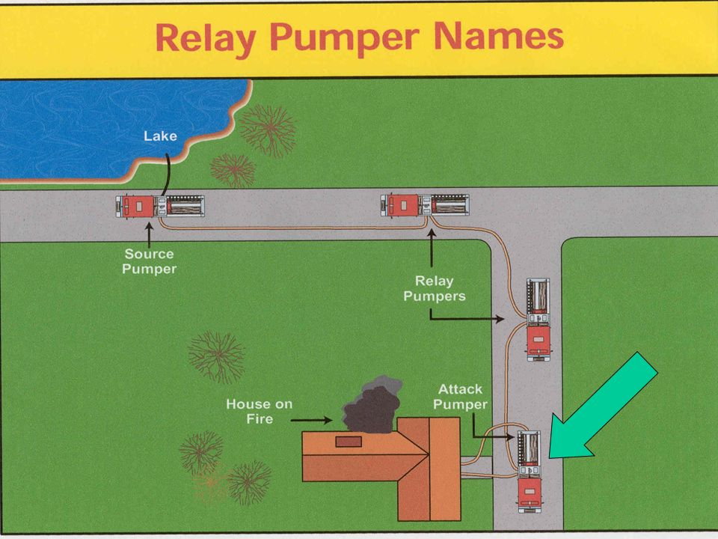

- Relay Pumping uses an engine at the water source to move water under pressure through a supply line, from one engine to the next

- The source engine boosts pressure to supply the next engine, and so on until the water reaches the fire ground
- No more than 1,000ft between each relay engine
- 50 psi to start with + Friction Loss to your next engine
- Determine the diameter of hose
- Determine length of hose

Tandem Pumping

Tandem Pumping- Is used when you want to overcome Friction Loss in elevation (High Rise) scenarios.
This process can be done by the first engine positioning on the FDC, and the second engine positioning close by the first in engine (rule of thumb within 50’). The second engine will connect soft sleeve or LDH from their discharge to the first engines intake. The second engine must have a secure water source!
If you are the engine connected to the FDC, you will want to make sure you are in VOLUME.

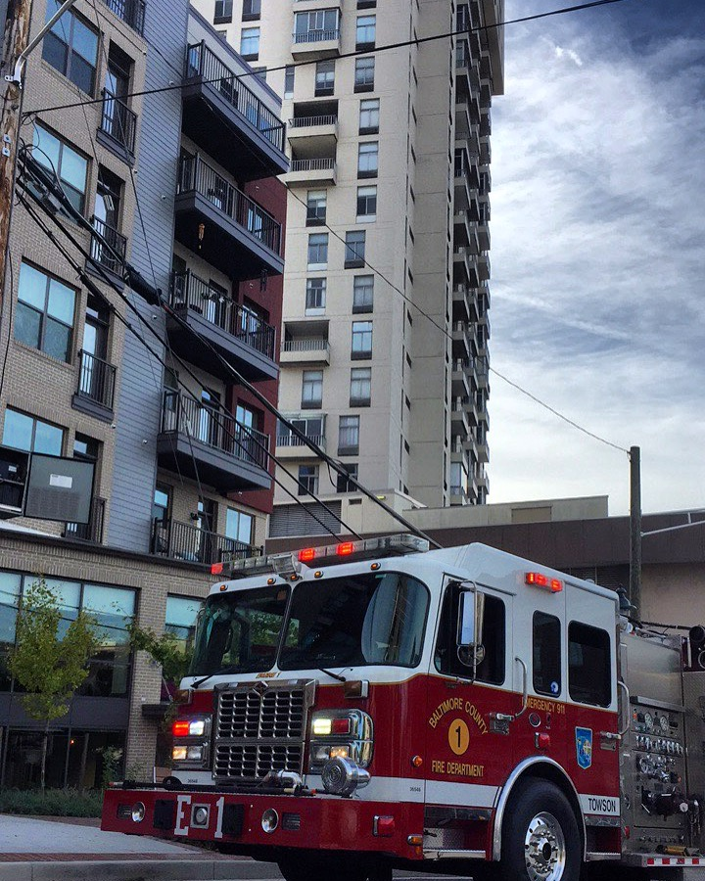

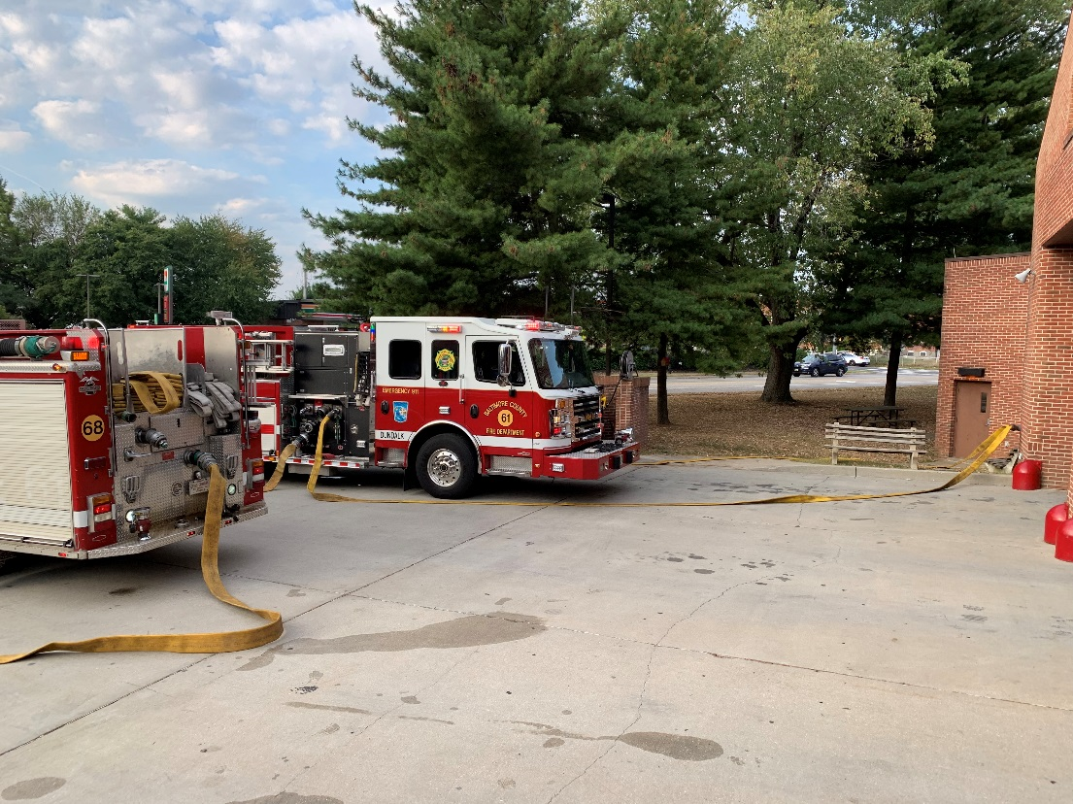
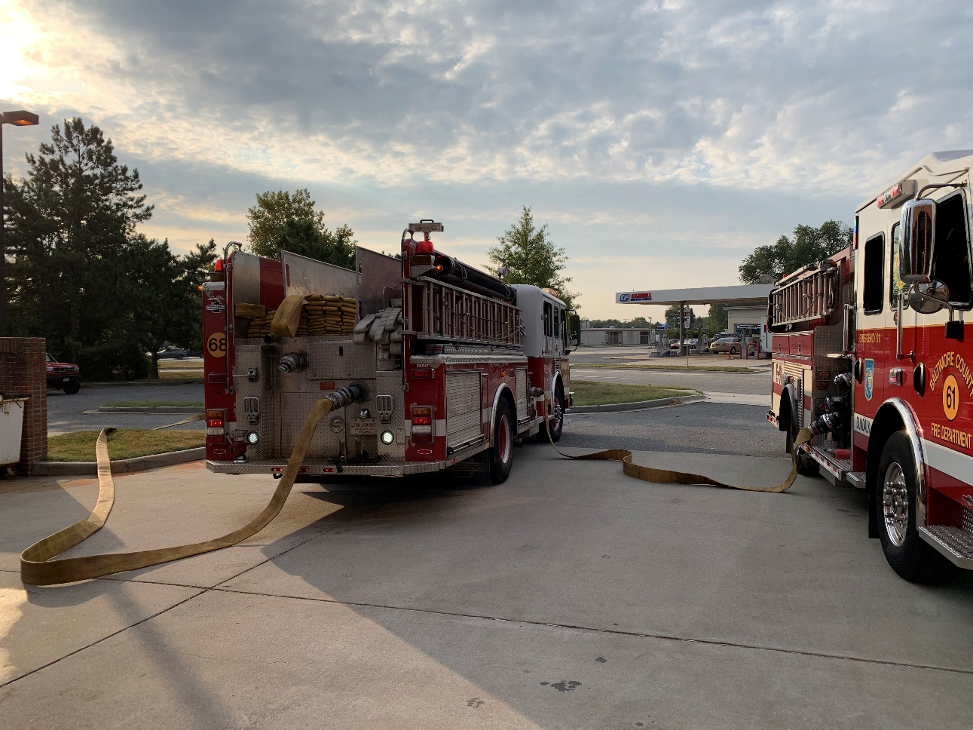

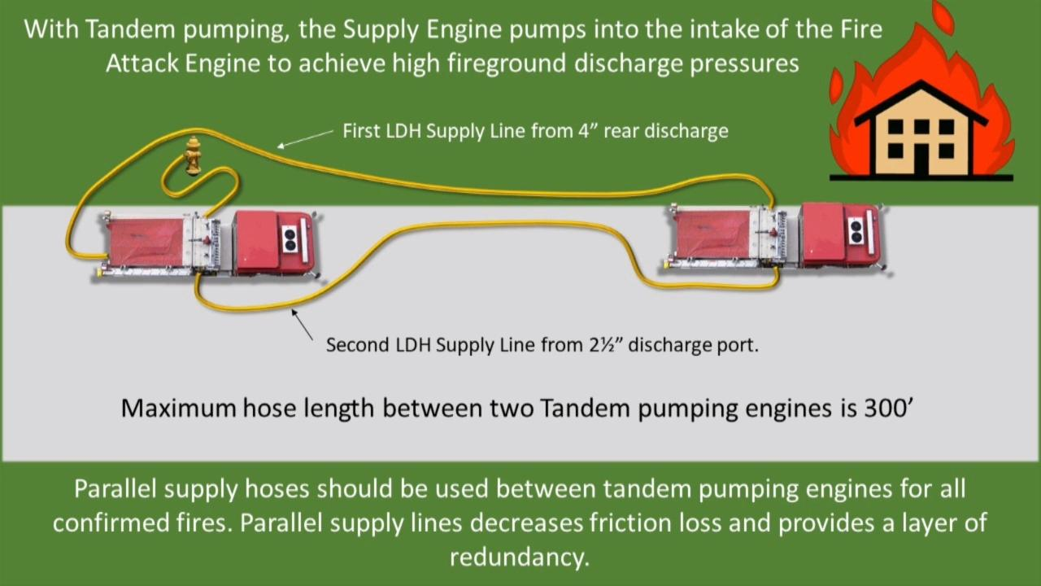

Dual Pumping

Dual Pumping can be done in many different ways. Dual Pumping is when one engine is on a secure water source, and has residual water to give to a secondary engine. Both engines can then flow hose lines but MUST watch their Intake / Discharge Gauges, specifically the engine that’s connected to the water source!
The following are ways to perform Dual Pumping:
- Engines connect a section of LDH from intake to intake
- Both engines hooked up to the hydrant
- Steamer Fitting to Steamer Fitting – (2) 3” inch hose lines from steamer fitting on pump panel to the other engines steamer fitting
- OLD SCHOOL mentality intake to intake with Hard Sleeve

Intake to Intake OR Discharge to Intake
When both intakes are open or discharge to intake are open, the second engine will receive the unused residual water from the first engine, allowing the second engine to place additional hose lines in operation.
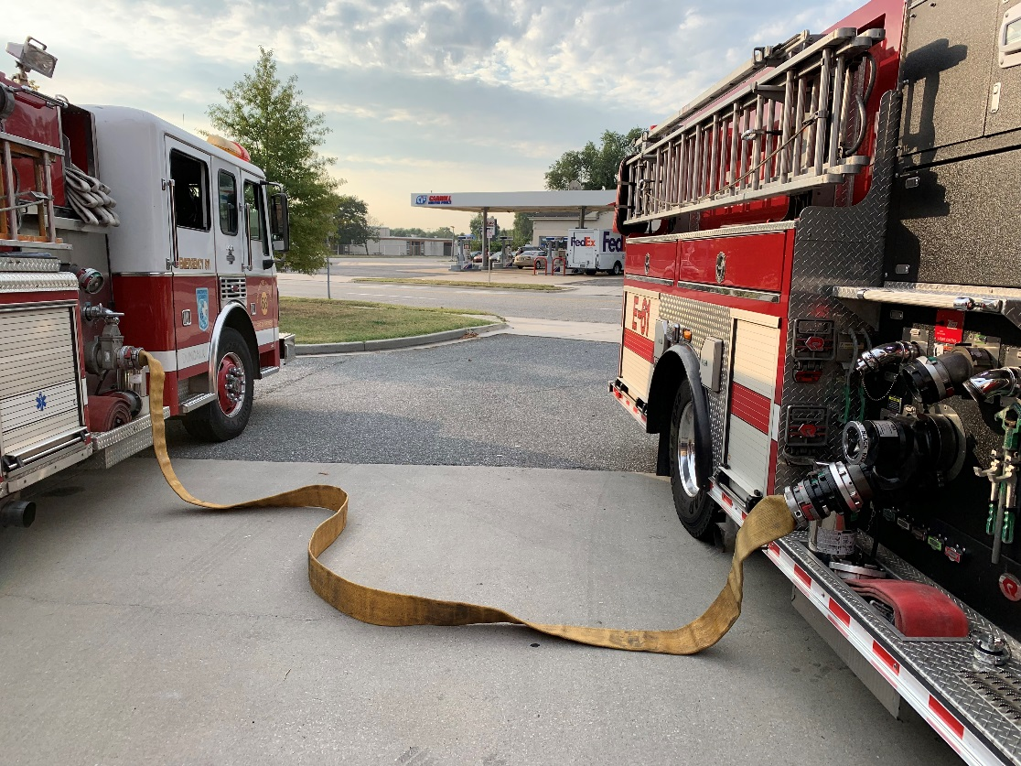

Both engine hooked-up to the hydrant:
The first engine has water coming into them from being hooked up to the 4 ½” outlet on the hydrant via soft sleeve.
The second engine is hooked-up to both 2 ½” outlets on the hydrant via ball valves, and two three in lines from the ball valves to the engine steamer fitting or direct tank fill.
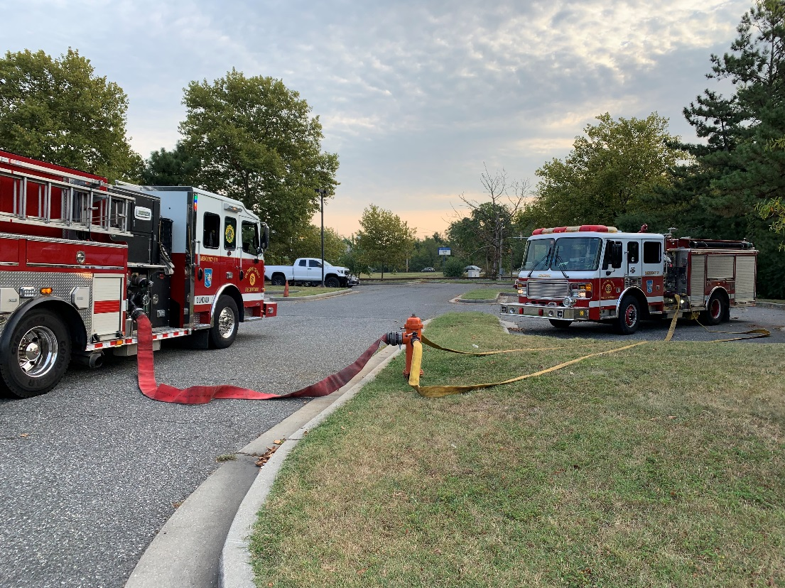

Steamer Fitting to Steamer Fitting:
First Engine connects to the front 4 ½” threats of the hydrant (utilizing the 5” or 6” soft sleeve), and the Second Engine connects (2) ball valves on both sides of the hydrant utilizing the 2 ½” threats and then connecting (2) 3” hose lines from the ball vales to the engines steamer fitting.

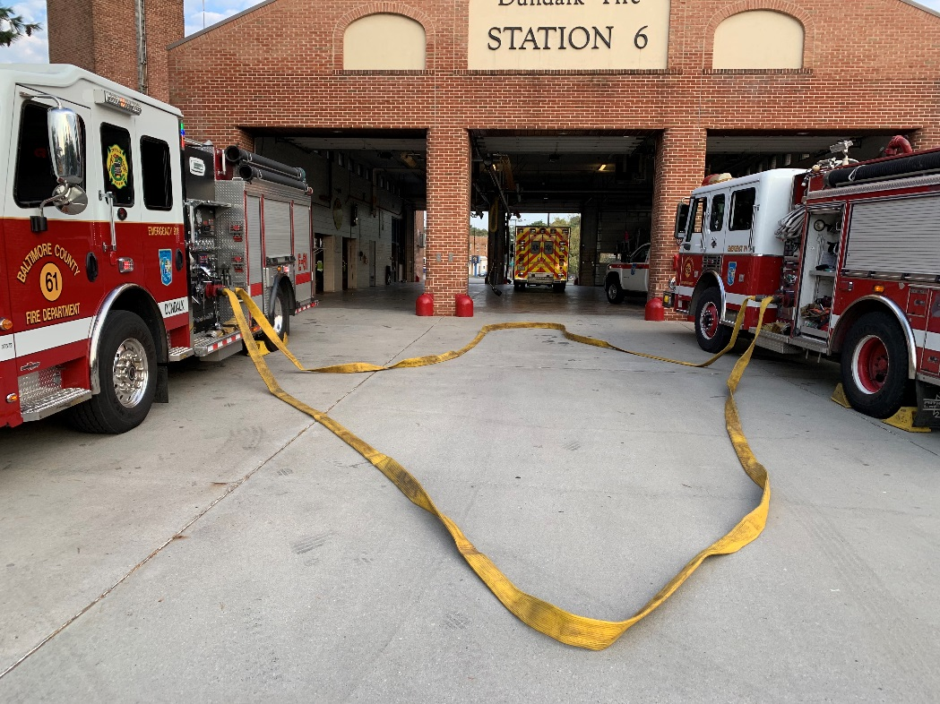

Utilizing the Hard Sleeve:
Using the Hard Sleeve, you will connect Intake to Intake removing the steamer fittings on both engines pump panel. HOWEVER this method is NOT preferred anymore due to ALL engines in Baltimore County carrying NEGATIVE PRESSURE Hard Sleeves. These Hard Sleeves should not exceed 20psi.

Other photos:
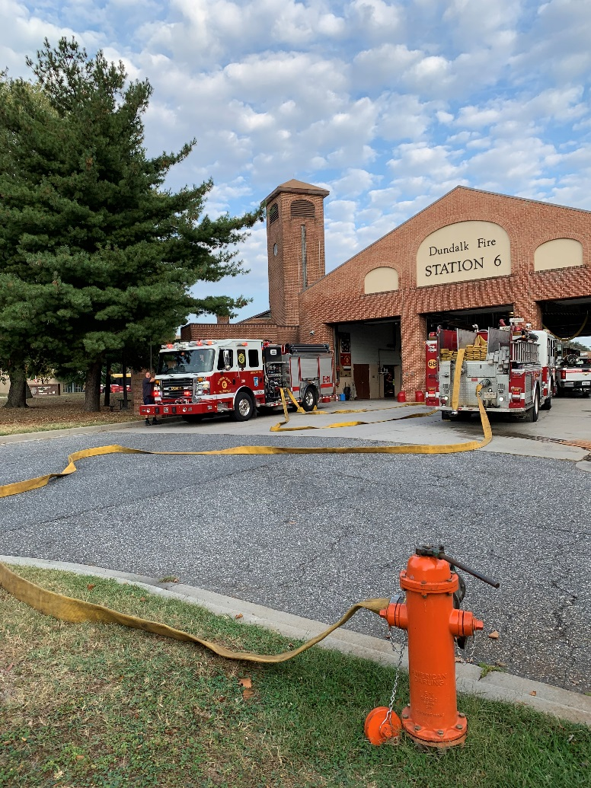
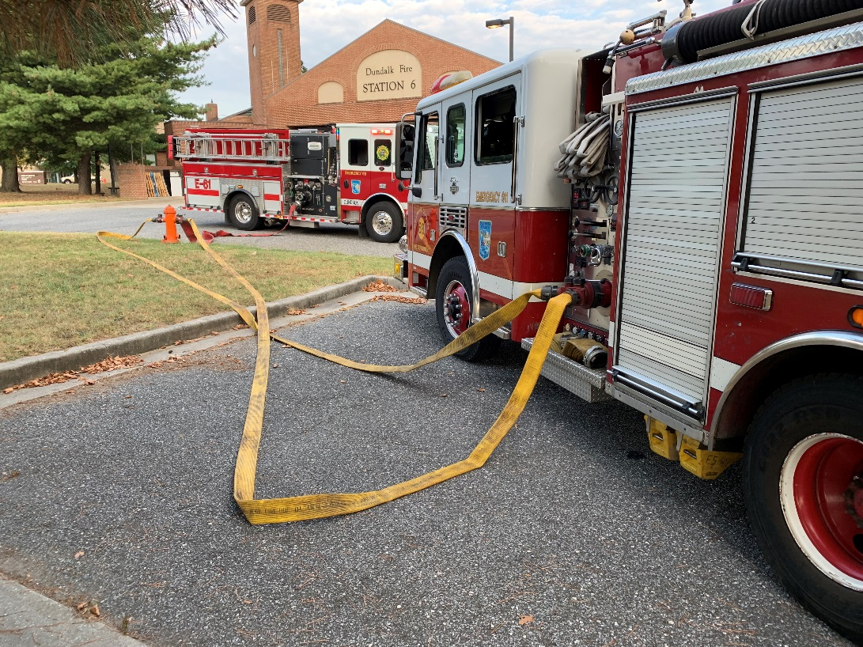

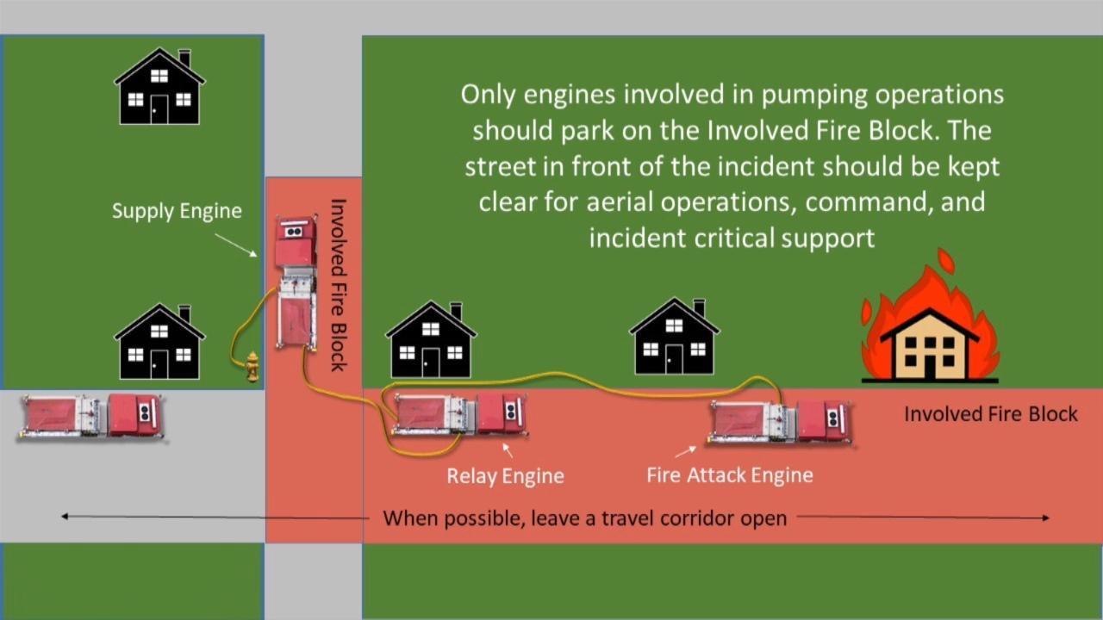
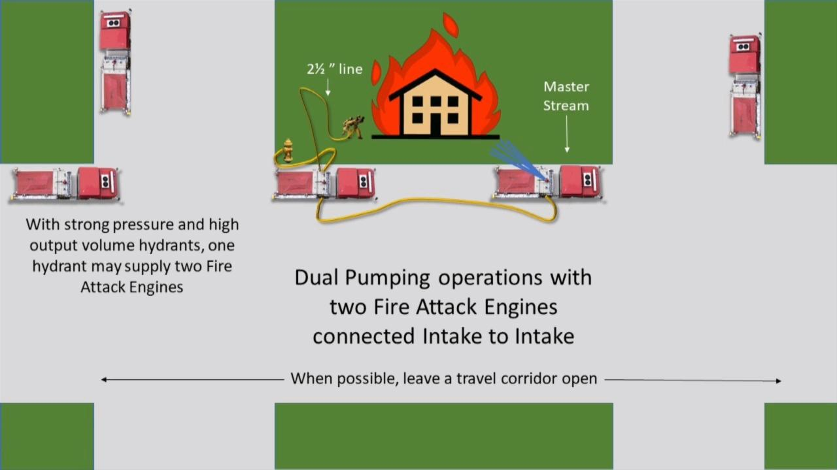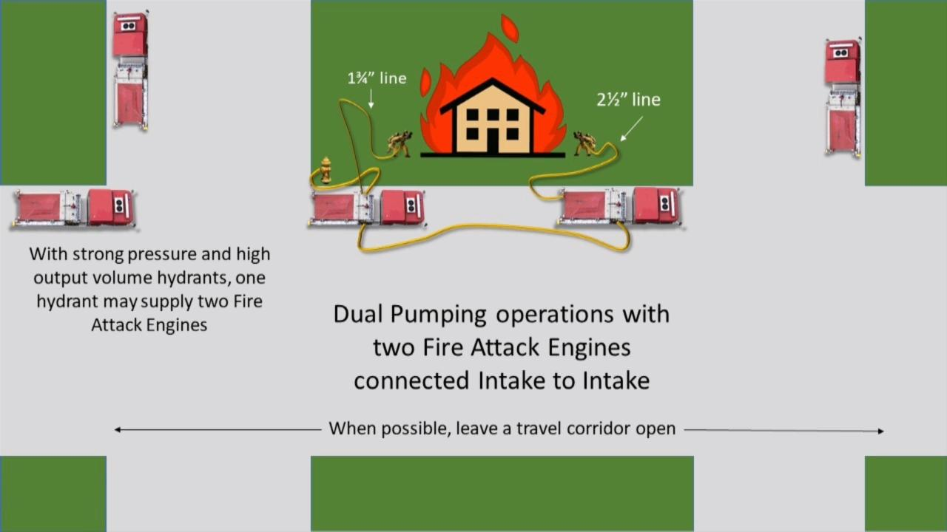

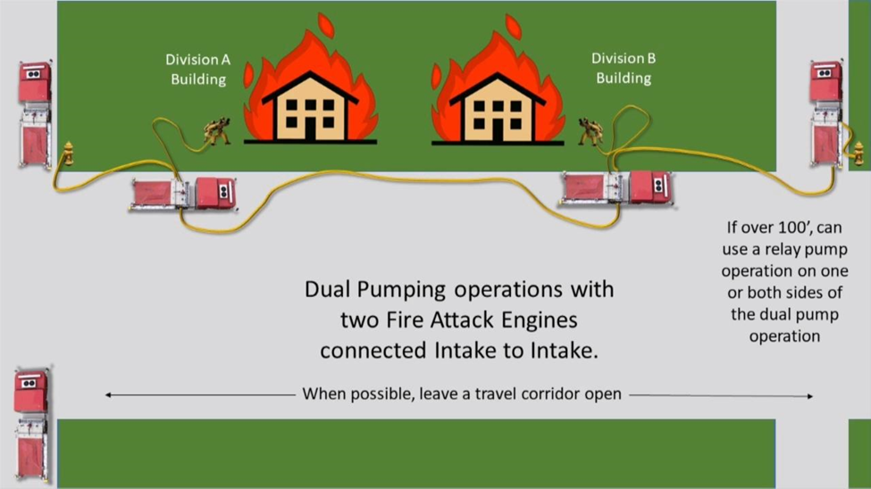

Drafting

This is a common method to establish a Rural Water Supply, it can be done multiple different ways.
- Dry Hydrant
- Under Ground Tank
- Fold-a-Tank
- Static Water Source
- Lake
- Pond
- Pool
- River
- Bay
- Etc.
Drafting is creating a vacuum in the pump, and atmospheric pressure forces water into the pump.

- Drafting – Raising water from water source to the pump

- Lift – Elevation difference between the water source and pump intake

Rules for Drafting:

- Determine where on the Engine you will be Drafting from (Pump Panel, Rear)

- Position the Engine 10’ to 12’ from where you will be drafting from (i.e. Dry Hydrant, Static Water Source)

- Put the Engine into Pump Gear

- Remove the steamer fitting from the pump panel, Jaffrey Valve Intake on the officer’s side, or Rear inlet (whichever you choose to take off based on positioning)

- Hook-up the hard sleeve to which ever inlet you choose

- Make sure all Discharges, Drains, are closed along with your TANK FILL and TANK to PUMP being closed as well “Air Tight”

- Place the other end of the hard sleeve after its hooked up to the engine, to you drafting site or by placing it in the water (may need two or three hard sleeves)

- Select RPM MODE on your pump panel
- Throttle up to about 1200 RPM’s

- Pull PRIMER / or switch AUTO PRIME
- If Pulling PRIMER, no more than 30-45sec.

- Once the Draft is established, throttle back down

- You will need to flow some kind of Discharge or “Dump Line” to hold the draft once its established (also could use deck gun and flow water back into the water source if static water source)

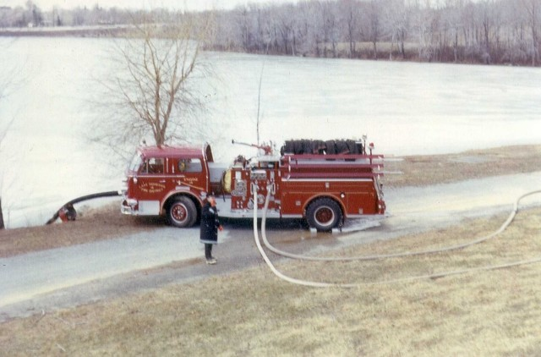

Things to Remember:
- Positioning no more than 10’ to 12’ from where you will be drafting from
- RPM Mode
- “Air Tight”
- Dump Line
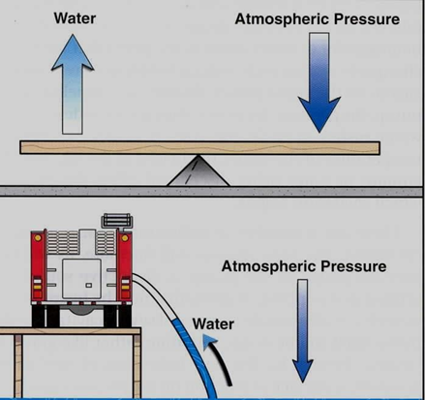
- Theoretical Lift 14.7

Strainer placement, if placing end of Hard Sleeve into the water;
- Try to leave 24 inches all around the strainer on the end of the Hard Sleeve
- Tie a rope around the strainer, and then tie the rope to something to be able to access it (may need to guide it or pull it at times)

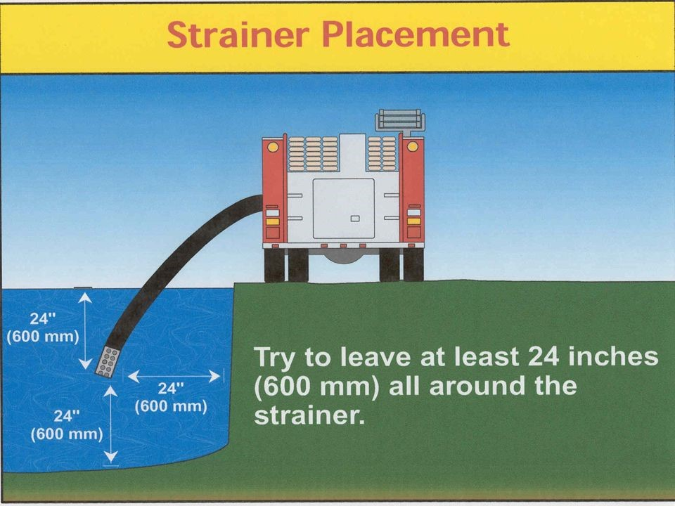

***Side Notes:
If you can’t pull a Draft due to the PRIMER… Open the TANK to PUMP, fill the hard sleeve with water from your tank. Then, close your TANK to PUMP! You can try the PRIMER again now, but if it does not work, Throttle up hard to pull water up into your tank. Remember if you chose to do this, once you get water into your tank, you must throttle back down.
Also if you can’t pull a draft notify command, try to have another engine/tanker locate and establish another water source. You may need to open your TANK to PUMP, and flush out your hard sleeve and strainer of any sediment build up in the water around the strainer.

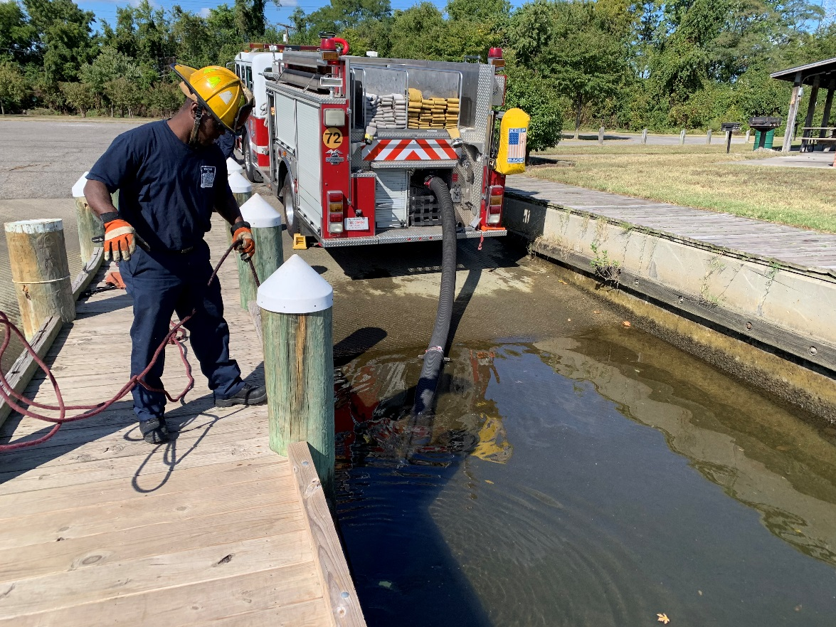

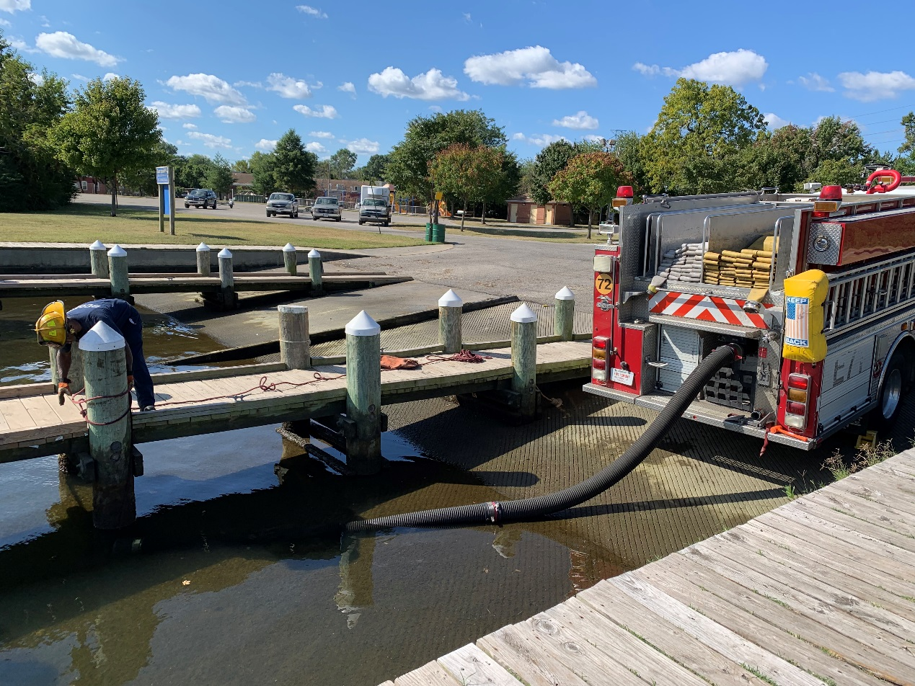

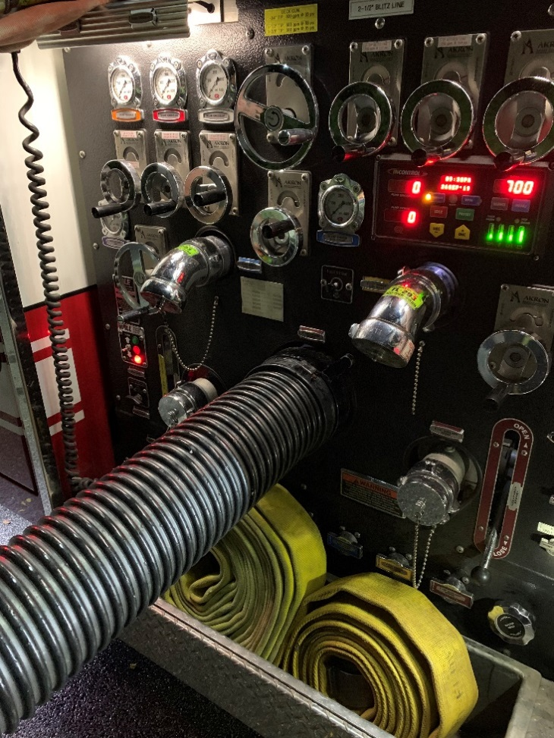
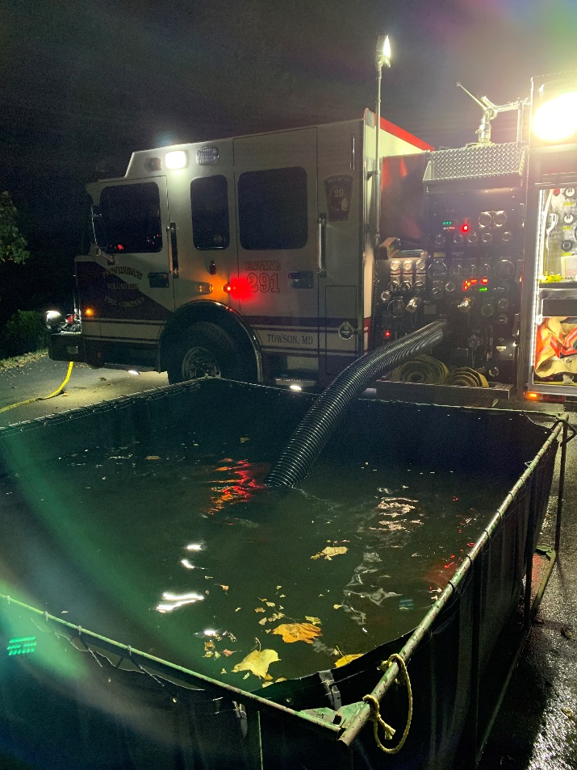

Back Flushing the Pump
Back Flushing the PUMP is done after any operation involving;
- Foam
- Drafting
- Rural Water Operations
- Also once a month (first Sunday) per BCoFD SOP’s

Follow the following steps to complete this process of Back Flushing;
- Position the Engine on a water source (hydrant)
- Take an inline Ball Valve 2 ½” threads, and connect to one of the side 2 ½” threads on the hydrant
- Use a 2 ½” hose line (short shot preferred) and connect the “female” coupling to the Ball Valve, and use a double female adaptor to connect to your highest discharge (Deck Gun if applicable)
- Remove any and all blind caps, screens, and disconnect any pre-connected hose lines
- Slowly charge the hydrant, introducing water into your hose line / Engine
- Open the Deck Gun (highest discharge) valve on the pump panel
- Rotate opening up all DISCHARGES and INTAKES 3-5 minutes each
- Once back flushing is complete, close all discharges and intakes
- Shut down hydrant, drain / disconnect 2 ½” hose and ball valve from the hydrant and engine
- Put back on all blind caps, screens, and reconnect any pre-connected hose lines
- Make sure the 2 1/2” hose line gets drained, and rolled back up, placed back in service
- Return any appliances used, back on the engine
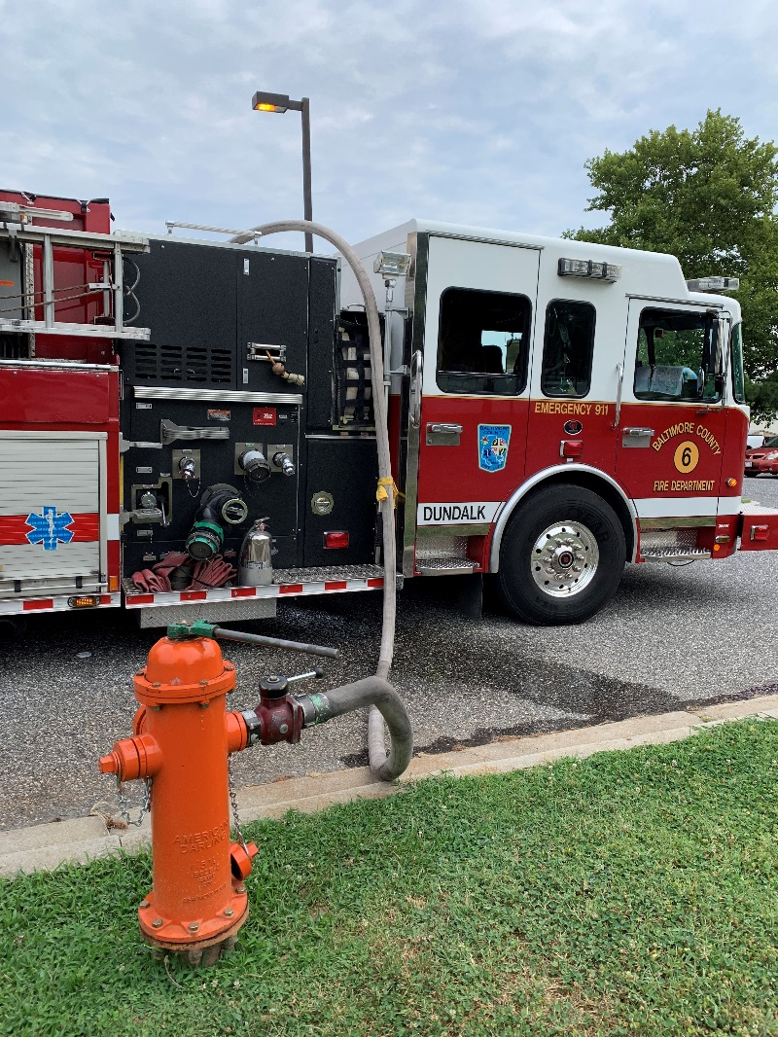
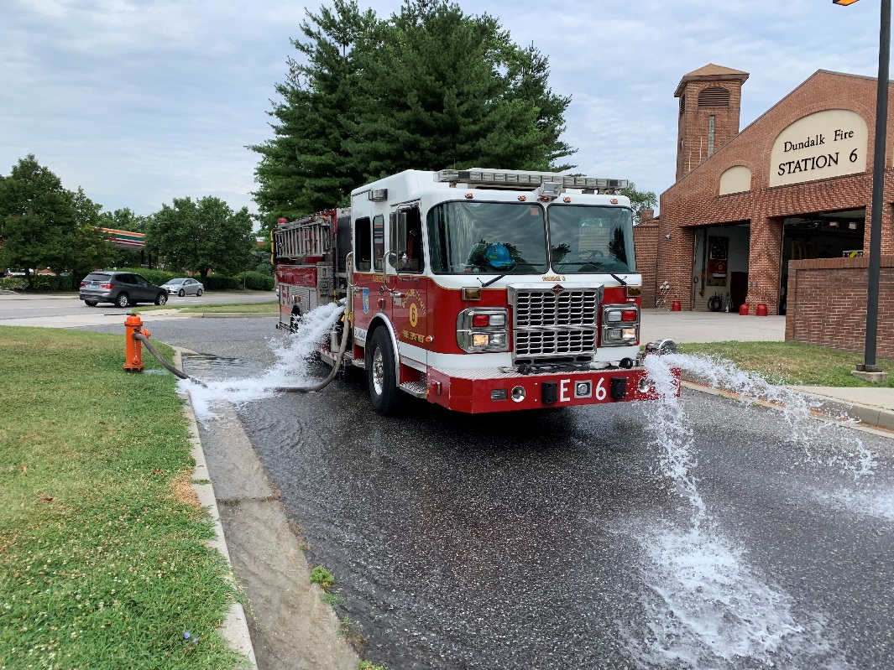

FOAM Educator/Midget

What kind of foam do we carry on our Fire Engines? And How much?
- AR-FFF (Alcohol Resistant Film Forming Foam)
- (3) – 5 Gallon Buckets
- Totaling 15 Gallons Per Engine

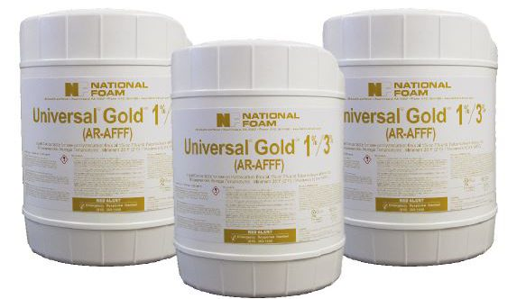

Eductor:
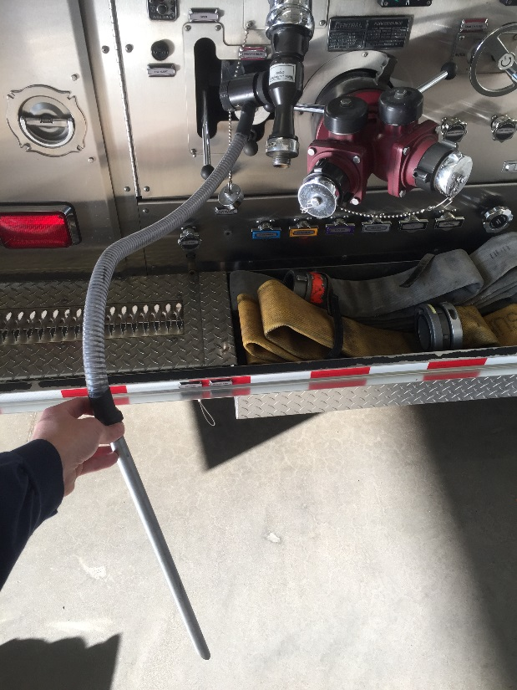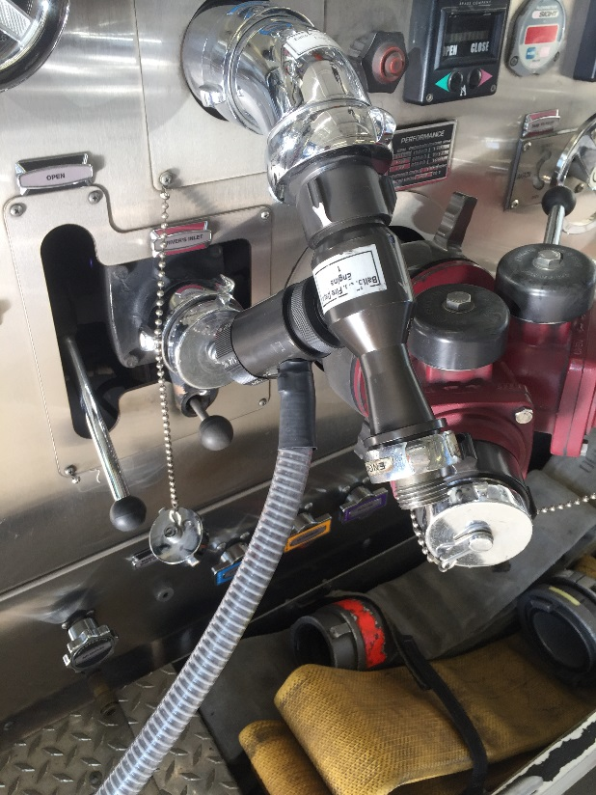

Rules pertaining to the Foam Eductor:
- Set Nozzle at 95gpm – Fog Nozzle or Play Pipe
- Pump Eductor at 200psi
- No more than 200’ of hose going forward from the Eductor
- No set limit in lengths of hose from pump to Eductor, as long as the Eductor can be pumped at the proper pressures
- Use Play Pipe Nozzle when possible

You can either hook up the Eductor right to a discharge, or to a hose line coming from the engine. Again no more than 200’ past the Eductor.

At 3%, 15 Gallons of Foam Concentrate Makes 500 Gallons of FINISHED FOAM

Midget:

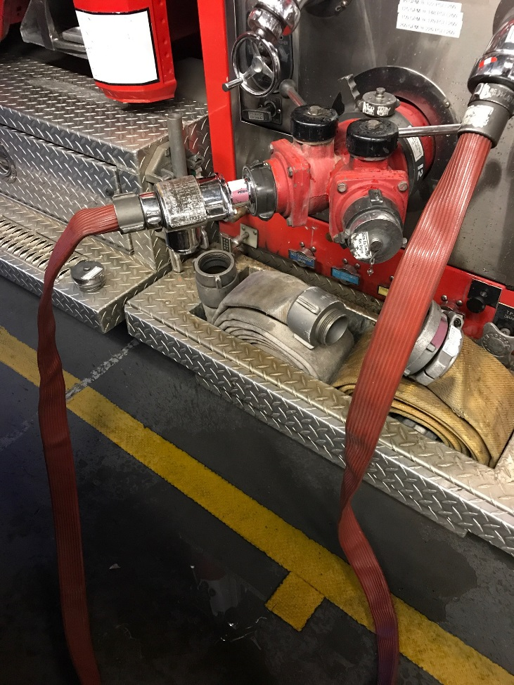

Rules pertaining to the Foam Midget:
- Set nozzle at 95gpm – Fog Nozzle or Play Pipe
- Hook Foam Midget up to the pump panel “intake”
- 3” supply line coming into “Direct Tank Fill”
- 1 ½” Red Hose from a discharge to the Midget
- Pump the Midget at 150psi
- Tank to Pump OPEN
- DO NOT OPEN TANK FILL

- Foam Midget – Flow Multiple Lines
- Pump Lines at 95gpm + Friction Loss

FDC Operations (Standpipe – Sprinkler)
Standpipe Operations:
- Secure a water source
- No more than 150’ from the FDC
- (2) 3” Hose lines, from the Engine Discharge to the FDC
- Maintain 150psi, + 5psi per floor above ground floor
- Max. Pressure 200psi

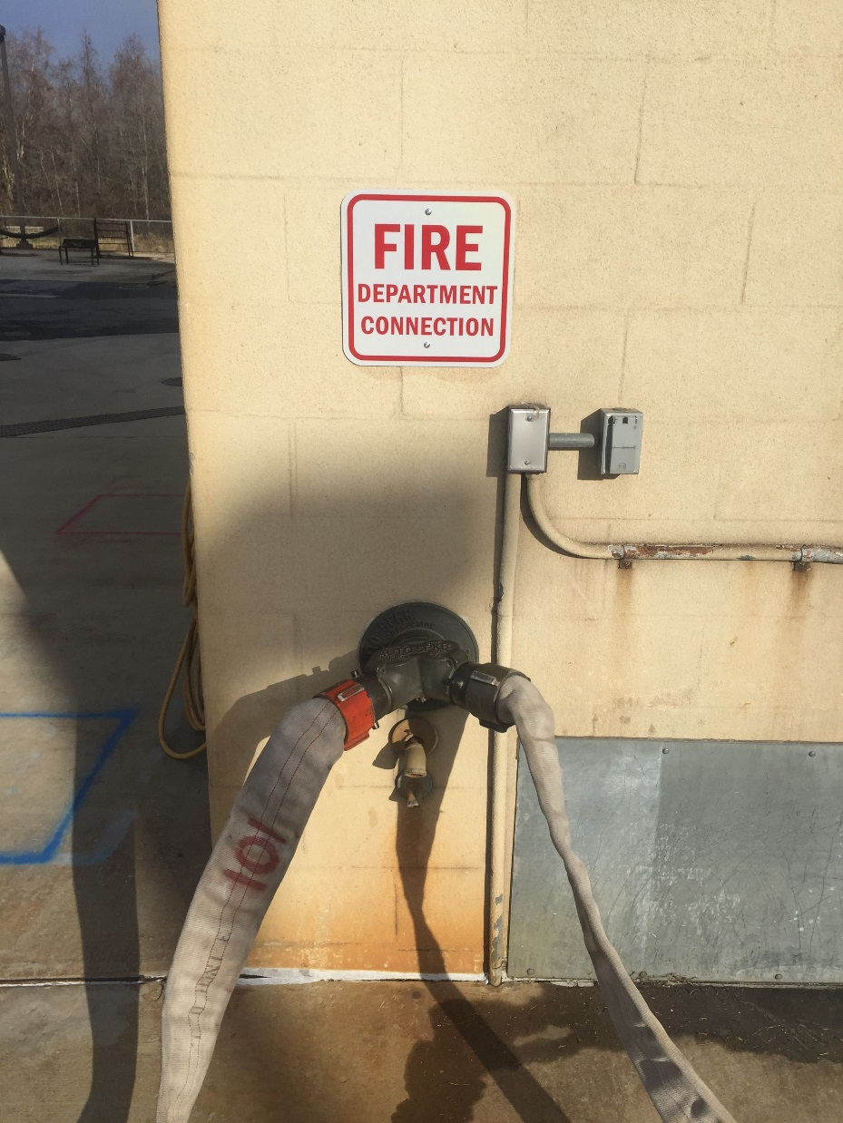

Sprinkler Operations:
- Secure a water source
- No more than 150’ from the FDC
- (2) 3” Hose lines, from the Engine Discharge to the FDC
- Maintain 150psi, + 5psi per floor above ground floor
- Max. Pressure 200psi

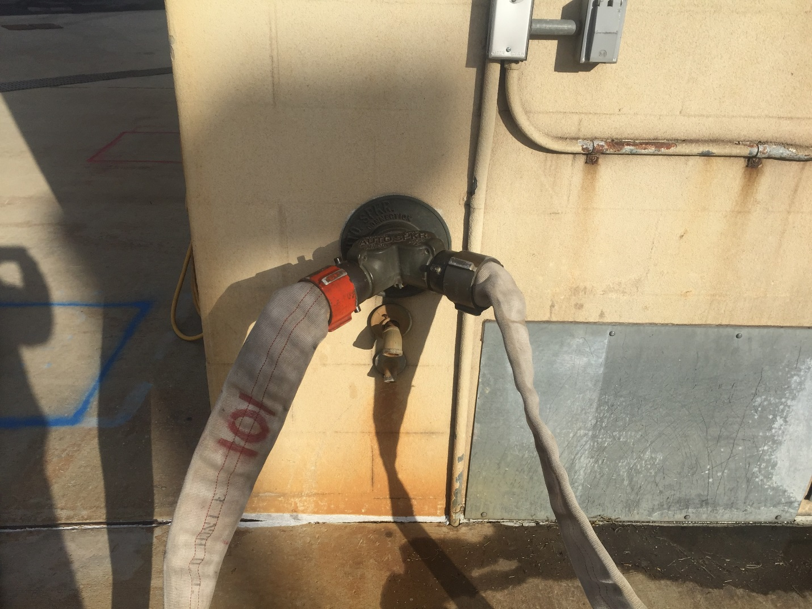

Dry Standpipe
When standpipes are fixed into buildings, the pipe is in place permanently with an intake usually located near a road or driveway, so that a fire engine can supply water to the system. The standpipe extends into the building to supply water to the interior of the structure via hose outlets, often located between each floor in stairwells in high rise buildings. Dry standpipes are not filled with water until needed.

Wet standpipe
A "wet" standpipe is filled with water and is pressurized at all times. In contrast to dry standpipes, which can be used only by firefighters, wet standpipes can be used by building occupants. Wet standpipes generally already come with hoses so that building occupants may fight fires quickly. This type of standpipe may also be installed horizontally on bridges.

What happens when the FDC is compromised?
If you run into this problem, what are you going to do? Your crew is going to be expecting you to get them water!
Thinking outside the box…
You can take a 3 inch hose line from your engine into the building, and connect to the standpipe. You will make this connection a floor above the ground level floor. You will need assistance with making this connection, so utilize the second in engine driver/personnel.

***REMEMBER***
Remind your engine crew as they advance up the stairwell in a high rise situation, they are checking to make sure the caps are connected to the standpipe, so that water doesn’t blow out of any open caps below the fire floor.

2” Hose High Rise Packs

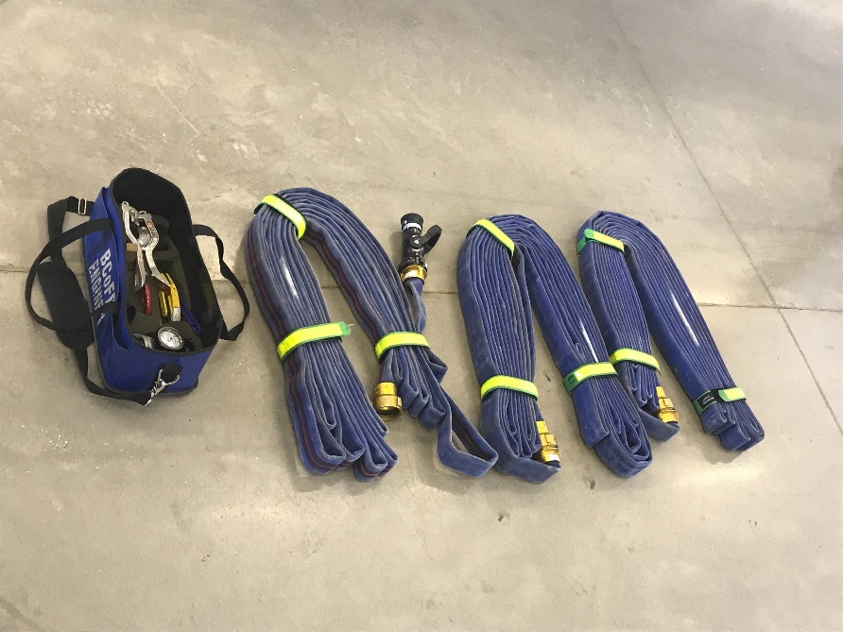
(3) – 75’ Sections of 2” Hose
Smoothbore Nozzle
1 1/8” Tip
265gpm
50 psi NP

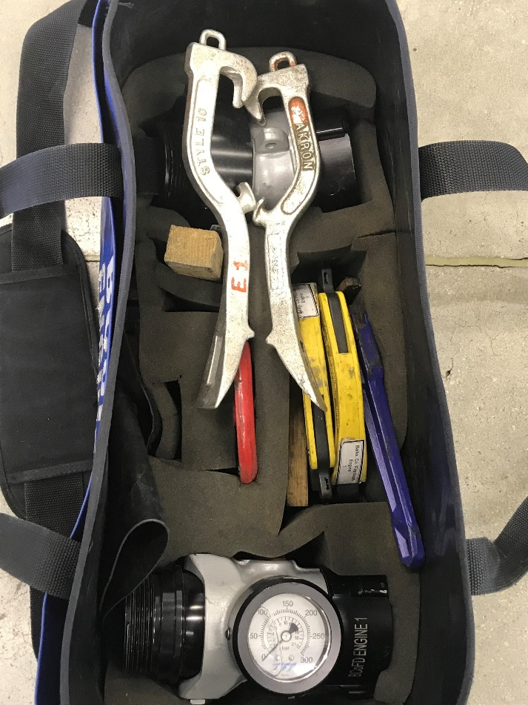
High Rise Bag:
- Elbow
- Gauge
- Spanner Wrench
- Wood Chock(s)
- Spare Steal FDC Wheel

Pumping the 2” High Rise Pack

(FL) Friction Loss – 20psi per 75’ section
(NP) Nozzle Pressure – 50psi
Add 5psi for Elbow

# Sections | Pressure | PSI at the Standpipe
- – 75’ | 75psi | 90psi + Elev.
- – 75’ / 150’ | 95psi | 110psi + Elev.
- – 75’ / 225’ | 115psi | 130psi + Elev.

FDC Pump Pressure NOT to EXCEED 200psi

FDC Pressure includes 15psi for System Losses

Break Down on how to Pump the High Rise Pack:

1 – 75’ section:
20FL + 50NP + 5psi = 75psi
Add 15psi for system losses, 75 + 15 = 90psi

2 – 75’ sections:
2x20FL = 40 + 50NP + 5psi = 95psi
Add 15psi for system losses, 95 + 15 = 110psi

3 – 75’ sections:
3x20FL = 60 + 50NP + 5psi = 115psi
Add 15psi for system losses, 115 + 15 = 130psi

How to Pack the High Rise Pack

Step 1: Start with the “Male coupling” and estimate 32”
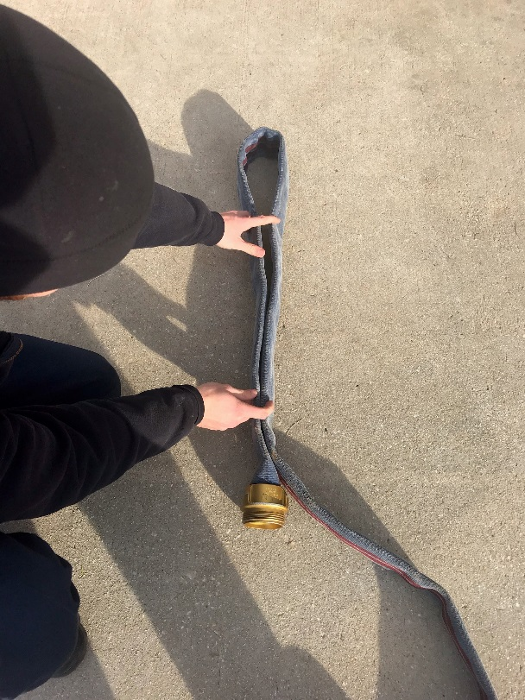

Step 2: Fold the hose back and forth, around itself “U” shape
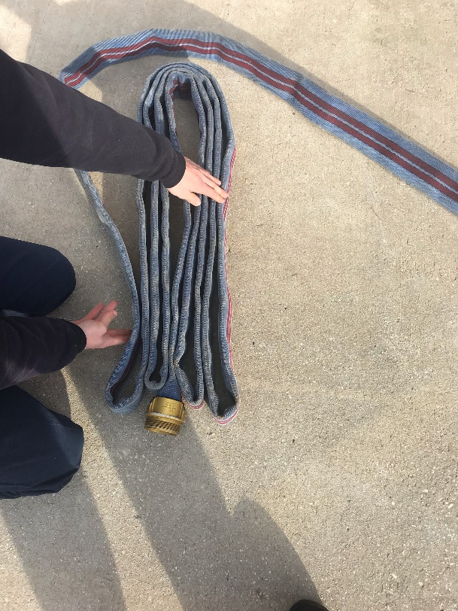

Step 3: When finished, connect the couplings and place the green straps on the hose.
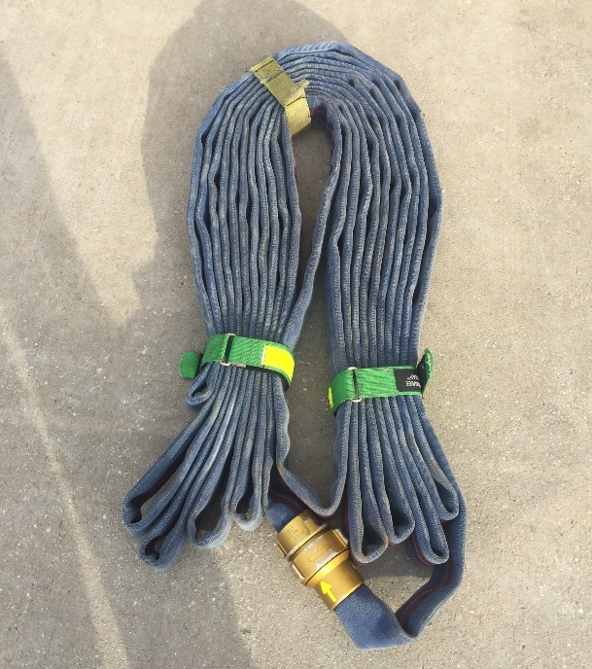

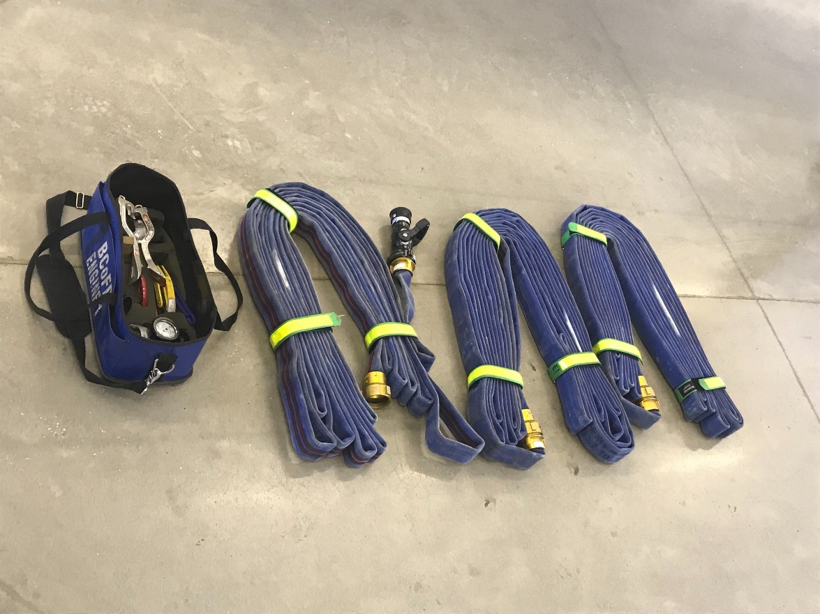

Wyed Attack Lines

How to pump “Wyed” Hose Lines?!

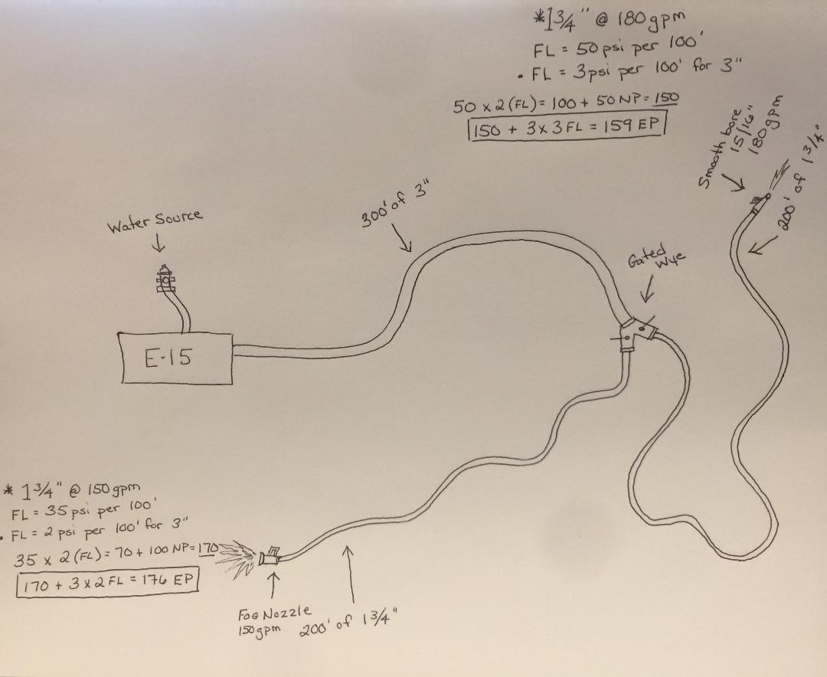
(Picture not to scale)
Determine which Hose Line going forward from the Gated Wye, has the Highest EP (GPM – FL – NP)
Then, based off of the GPM from that hose line, Figure out the FL for the 3”
Manually Gate the other Hose Line on the gated wye, to keep from over pressuring (If not the same size hose, length, nozzle).
Don’t forget to add 10psi for the Gated Wye

Pumping Multiple Lines

How do you do this correctly?
Determine what you are flowing, and how many hose lines you are flowing…
Remember you don’t want to overdo it and cavitate your pump, keep a close eye on your compound gauge for how much Residual Pressure you have.
Rule Of Thumb:
10% Drop - Add 3 additional Hose Lines of same GPM
Or 1 Hose Line next size up

20% Drop – Add 2 additional Hose lines of same GPM
Or 1 Hose Line next size up

30% Drop – NO MORE MAXED OUT

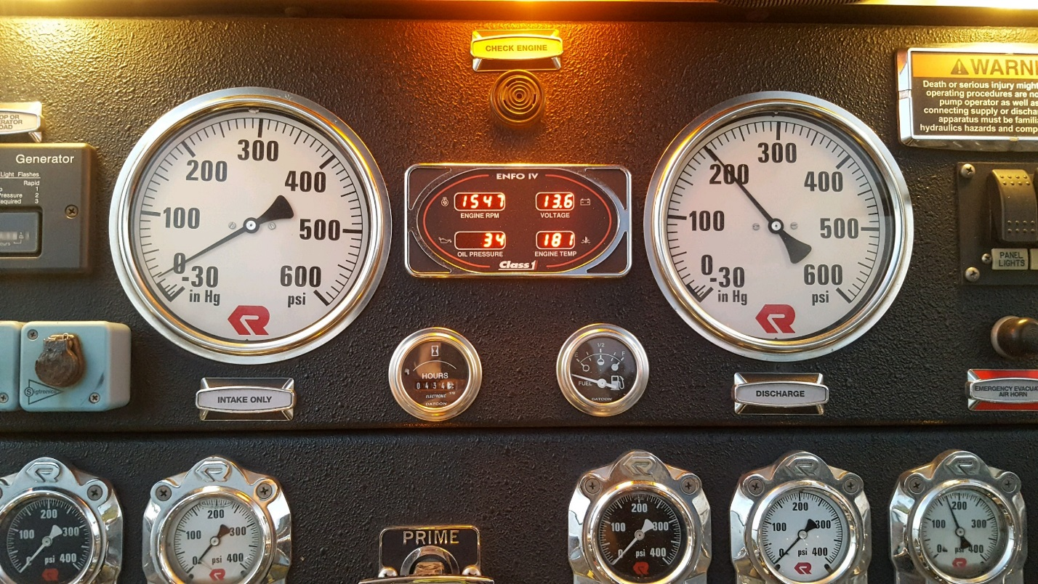

When flowing multiple hose lines, determine which hose line will have the highest Engine Pressure (EP), and set your discharge based on that. You will have to Gate back the other hose lines that you are pumping.

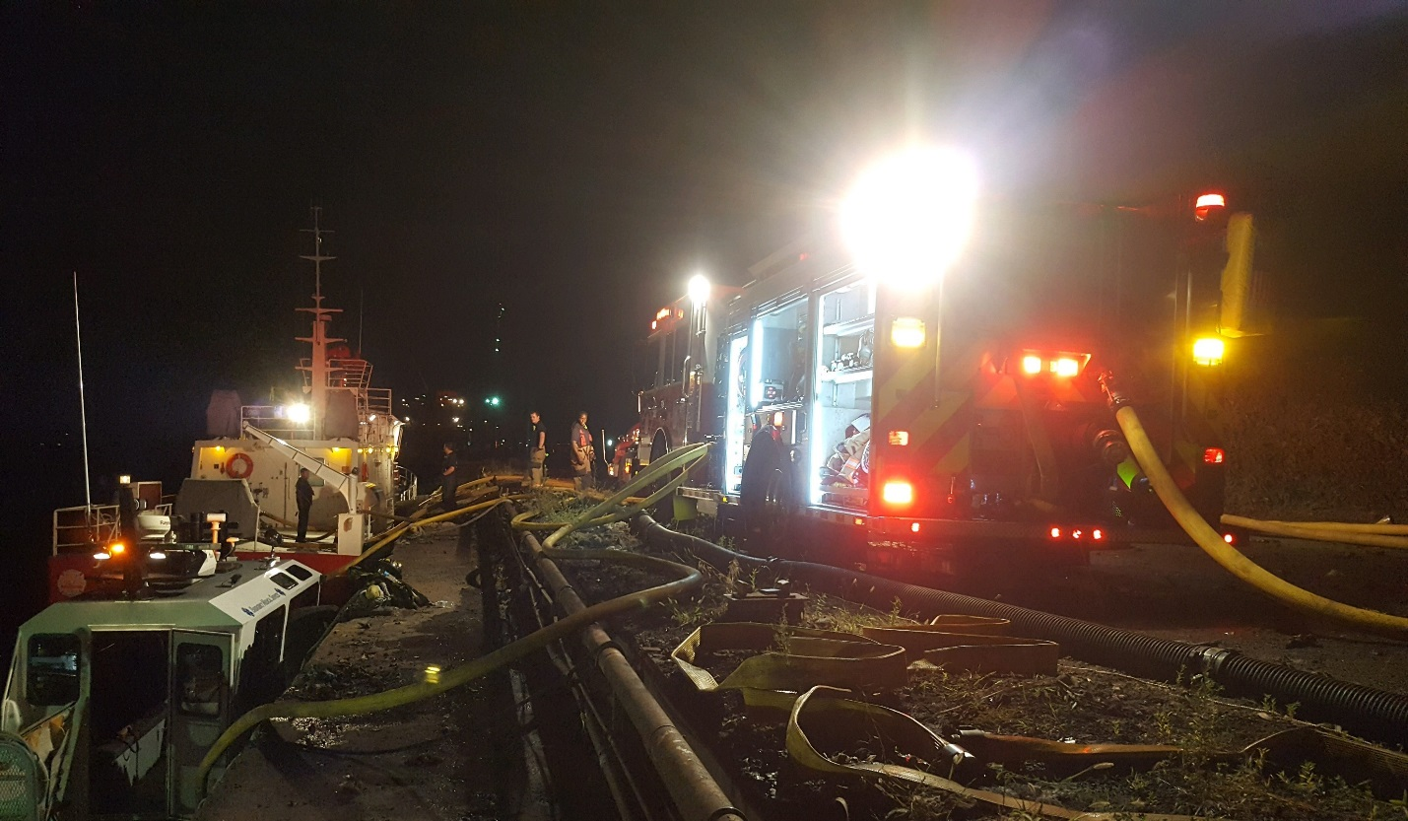

Example:
You are the Pump Operator of Engine 7 on a first in dwelling fire, and there is a water source secured. The firefighters of your crew stretched a 150ft cross-lay, and Engine 71’s crew stretched a 200ft back-up line. The Third Engine arrives, and comes up to your engine and stretches the Static Apartment line to the rear of the dwelling.
What is your Pump Pressures? And GPM’s? To determine your Fire Flow, add the GPM’s of each hose line together, and that gives you your Fire Flow.

E-7 Hose Line:
150’ of 1 ¾” with a constant flow nozzle – 150gpm
FL is 35psi per 100’ / 15psi per 50’ + 100psi NP
EP = 150psi

E-71 Back-up Line:
200’ of 1 ¾” with a Low Pressure Nozzle – 200gpm
FL is 60psi per 100’ + 75psi NP
EP = 195psi

Third Engines Hose Line (Rear):
150’ of 1 ¾” / 200’ of 2 ½” with a smoothbore nozzle 1” tip – 210gpm
Total Length 350
FL is 60psi per 100’ / 30psi per 50’ – 1 ¾”
FL is 8 per 100’ / 4psi per 50’ – 2 ½”
EP = 156psi

Fire Flow = 560gpm
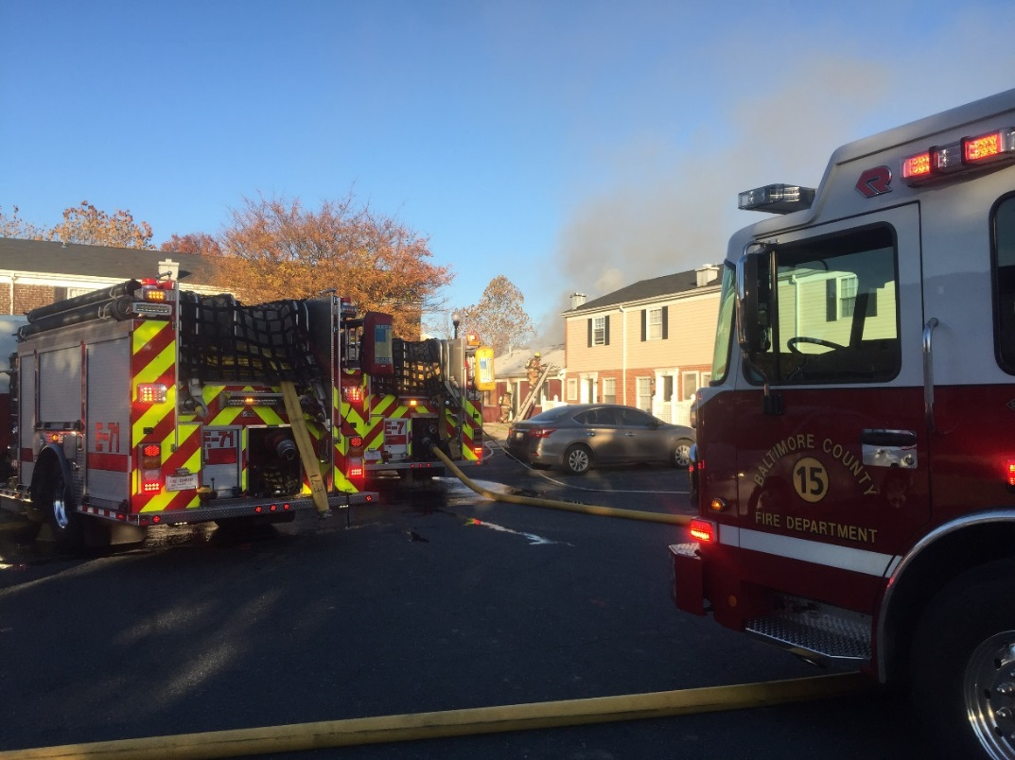

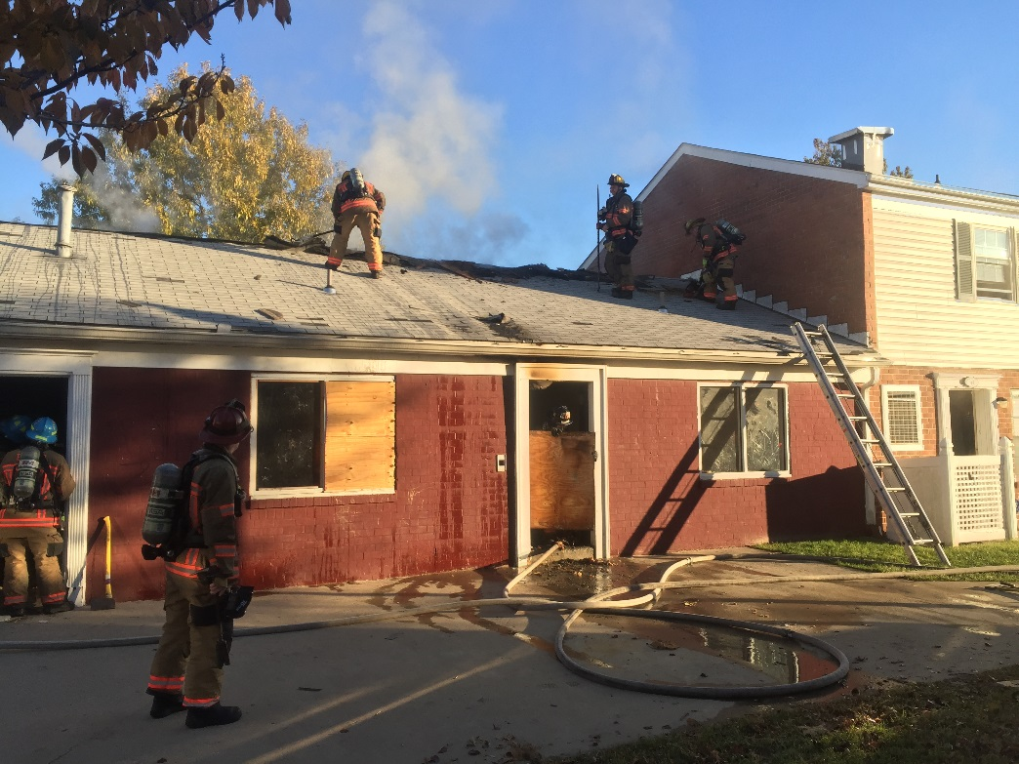

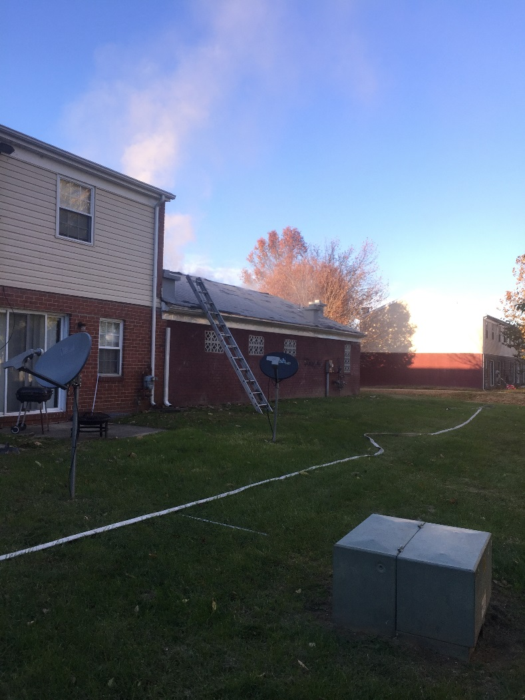

Pumping the Duce and A Half 2 ½” Attack Line

Pumping the Deuce and a Half (2 ½”):

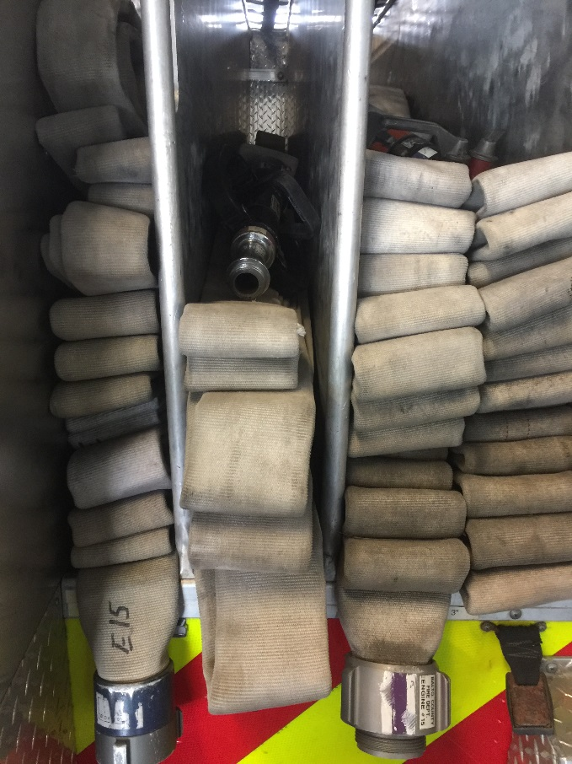

What you need to know?
- What type of nozzle? Fog or Smoothbore? Tip size?
- What is your GPM (gallon per minute)?
- How long is your Hose Line?
- What is your FL (friction loss) and NP (nozzle pressure)

Flowing and Pumping the 2 ½” can be done with the Fog Nozzle and Smoothbore Nozzle.
Fog Nozzle – 100psi for the NP
Smoothbore – 50 for the NP
If using the smoothbore, know which size tip!

Knowing your nozzles:

Fog Nozzle –
- NP = 100psi
- GPM settings 125, 150, 200, 250

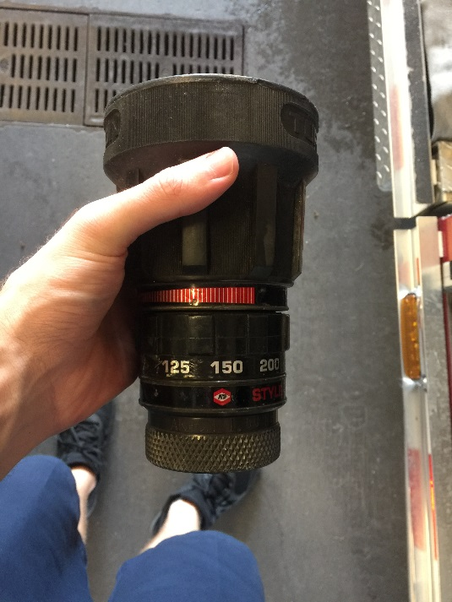

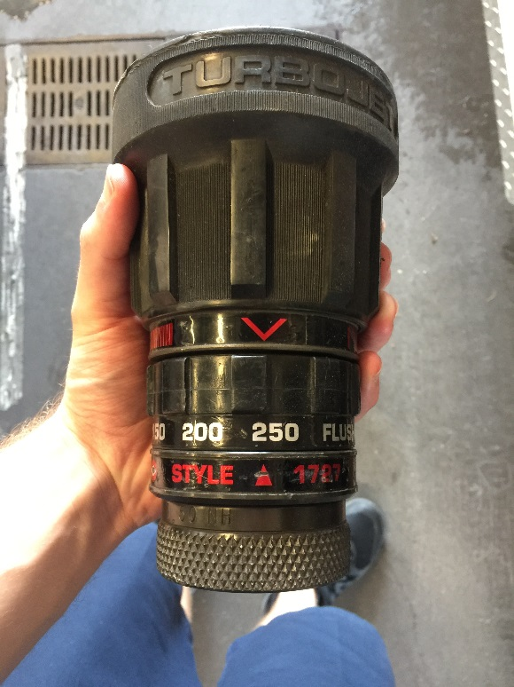

Smoothbore –
- NP = 50psi
- Tip Sizes / GPM
- 1 ¼” tip = 325gpm
- 1 1/8” tip = 265gpm

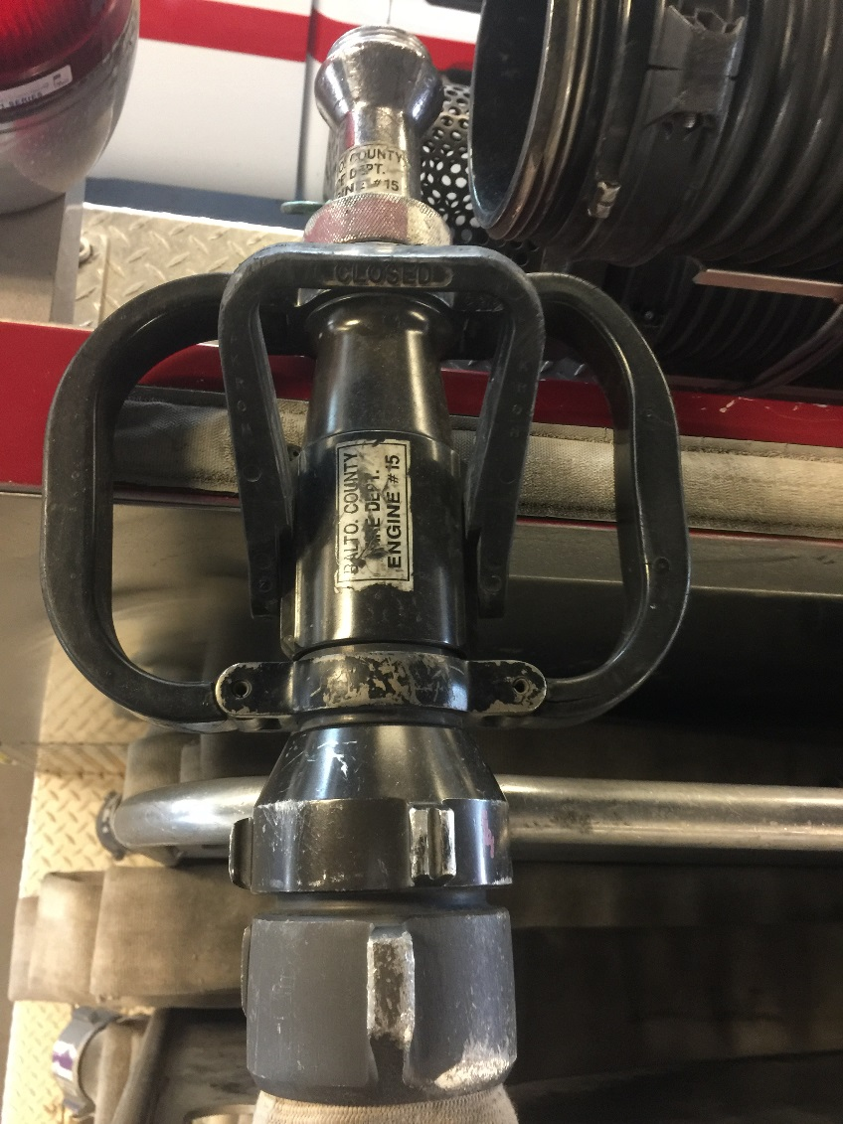

Pumping the 2 ½” Hose Line:

Example…
- 200’ of 2 ½” hose
- Smoothbore Nozzle – 50psi
- Tip size is 1 ¼” – 325gpm

@ 325gpm FL per 100’ of 2 ½” is 20psi / FL per 50’ of 2 ½” is 10psi
Length of Hose = 200’
NP = 50psi
GPM = 325

20 + 20(FL) + 50(NP) = 90psi

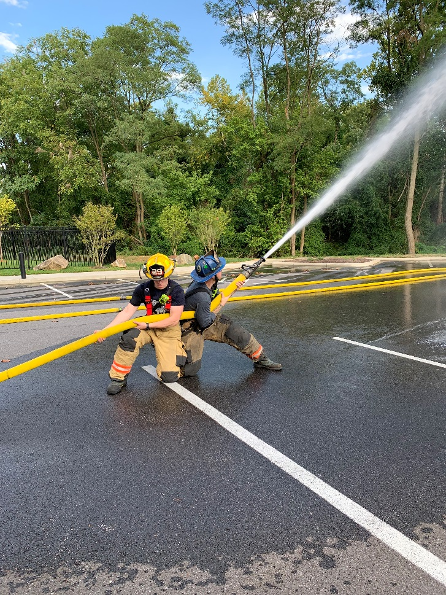

Apartment Line “Horse Shoe” Load
ENGINE 15
Apartment Line – “Horse Shoe” Load

Information pertaining to this line:
- Made up of 1 3/4” and 2 ½” hose
- 150’ of 1 ¾” hose
- 300’ of 2 ½” hose
- 450’ of hose total
- Static line – dead loaded
- Smoothbore nozzle – 1” tip – 209gpm

How the Horse Shoe load looks and is configured:
- Packed from Right to Left and Pulled from Left to Right
- 2 ½” hose single stacked, making two stacks of 150’ each, totaling in 300’
- 1 ¾” hose, 100’ with 3 loops and folds on top. (small loop, medium sized loop, and big loop)
- 1 ¾” hose, the last 50’ section made into the “horse shoe”

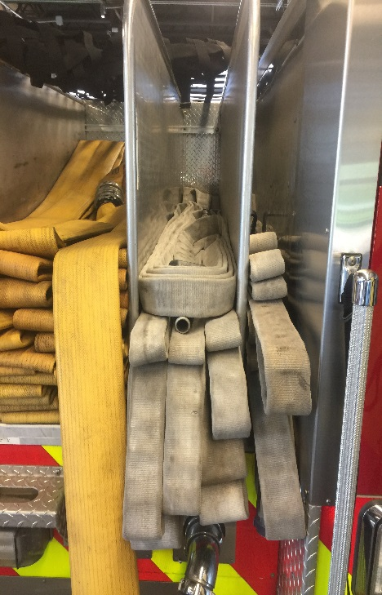

How the Horse Shoe line is pulled / deployed:

Step 1: Stand up on the tailboard of the engine, and grab the 50’ “horse shoe”. Grab ahold of the first 50’ by going under the hose, and then grabbing control of the nozzle.
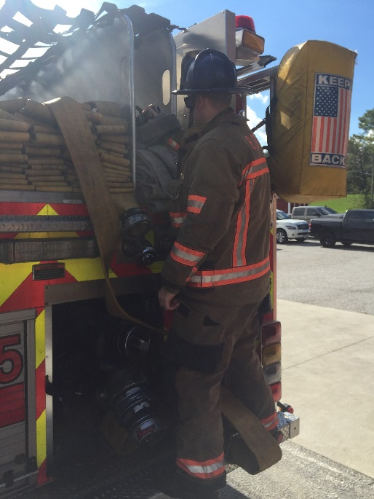
Step 2: Step down from the back of the engine, while maintaining control of the 50’ “horse shoe” and nozzle.
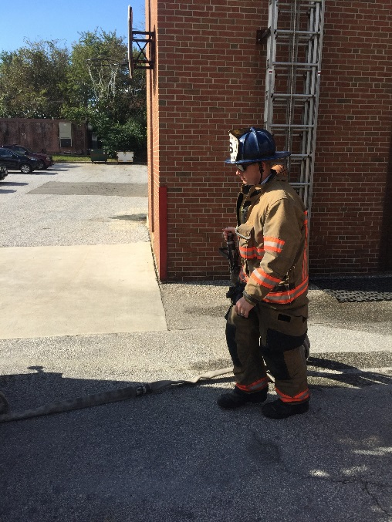

Step 3: With you free hand/arm, grab the loops (appropriate to what you need). Remember, pull Left to Right! If you pull all 3 Loops, you will end up with all 150’ of 1 ¾” hose out of the hose bed. If you pull the first 2 Loops, you will end up with 50’ of 1 ¾” in you free hand, giving you a 100’ total between both hands.
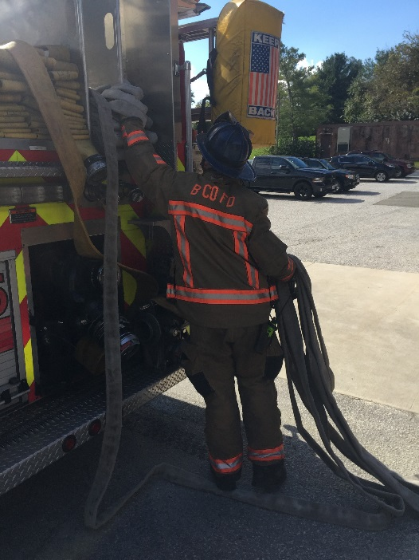

Step 4: Having control of the Loops now, pull the hose clear of the hose bed. If it’s going to be a long stretch, coordinate with your Back-up firefighter to prevent pinch points. Rule of thumb, account for a section of hose around each bend/corner.
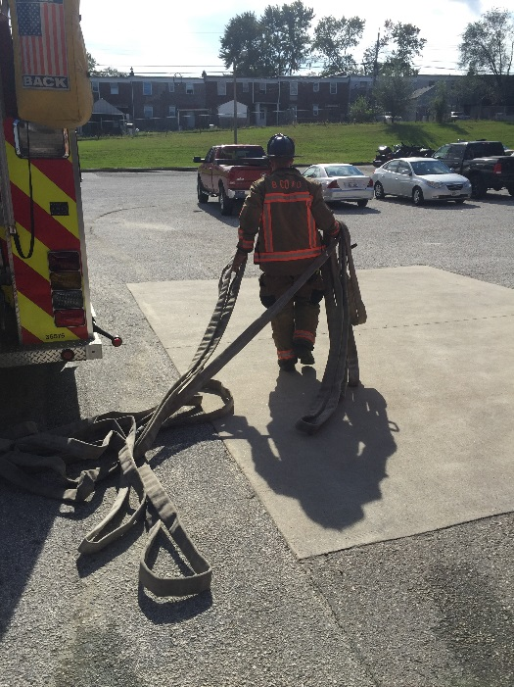

Step 5: While stretching hose, you have two sections, your stretching length you’re working length. During your stretch when it’s appropriate, start letting go of your hose around corners/bends. When it starts to pull tight, let go of the first loop. But remember to coordinate if it’s a long stretch. Never let go of your working length when deploying your stretching length.
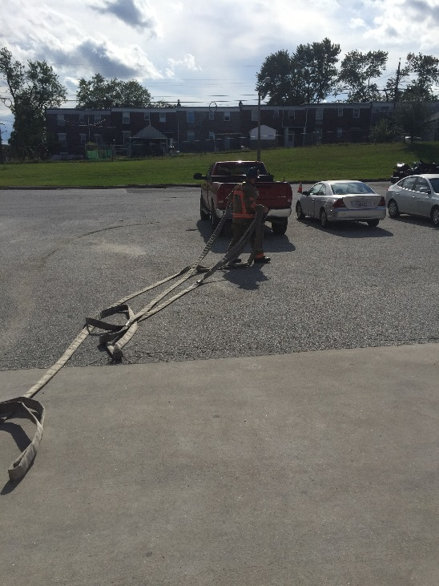

Step 6: Now, as you are approaching your target “entrance”… Approximately 30-35ft away, stop and deploy your working length.
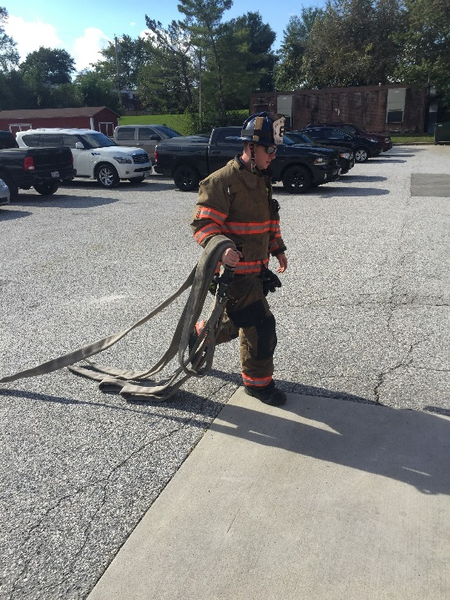

Step 7: Grab your Nozzle and coupling, and walking towards your entrance.
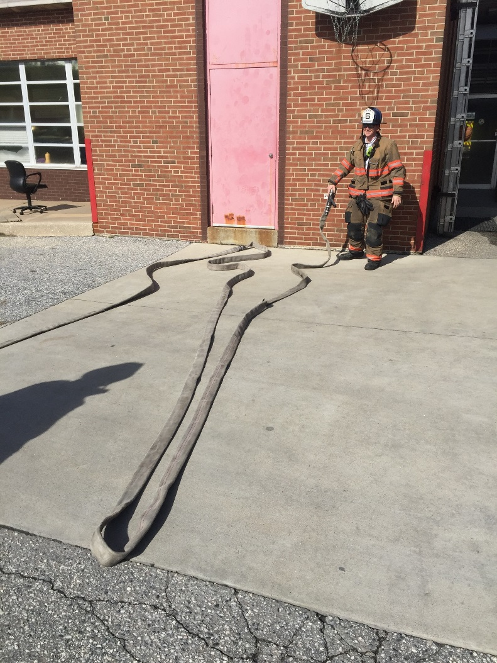

How is this line re-packed?
- Start with the 2 ½” hose, two single stacks – 150’ each, start from the right side
- Once the right and left stacks are made, connect the reducer fitting on the end of the 2 ½
- Connect the 1 ¾” hose, and start from right to left
- Make a Small Loop, then fold, Medium Loop, then fold, and then your Big Loop and fold
- Finally, make your 50’ Horse Shoe, and then lay it on top and connect it to the rest of the 1 ¾” line

(See pictures below to follow)

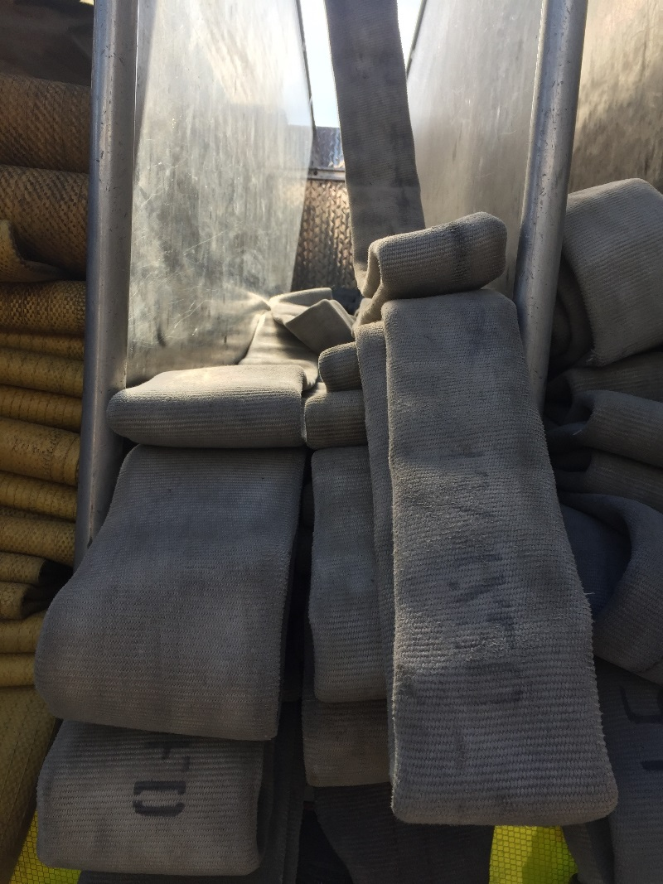

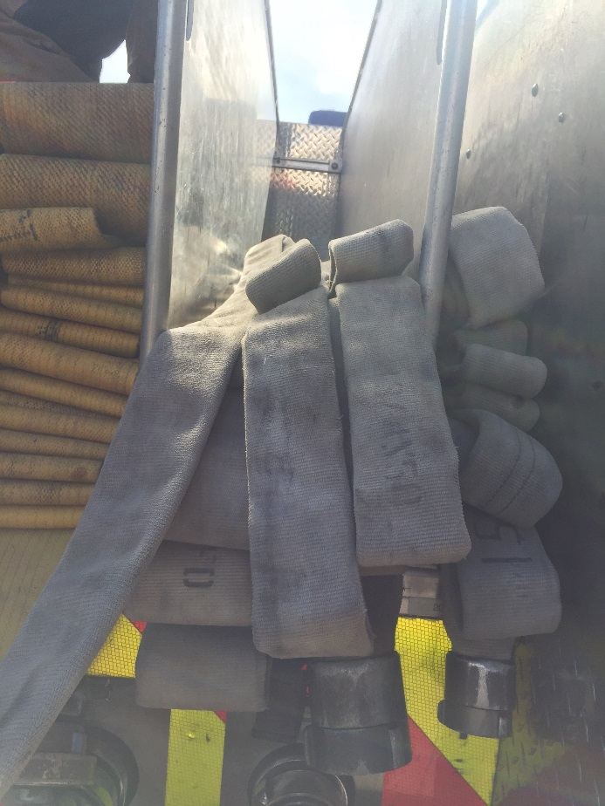

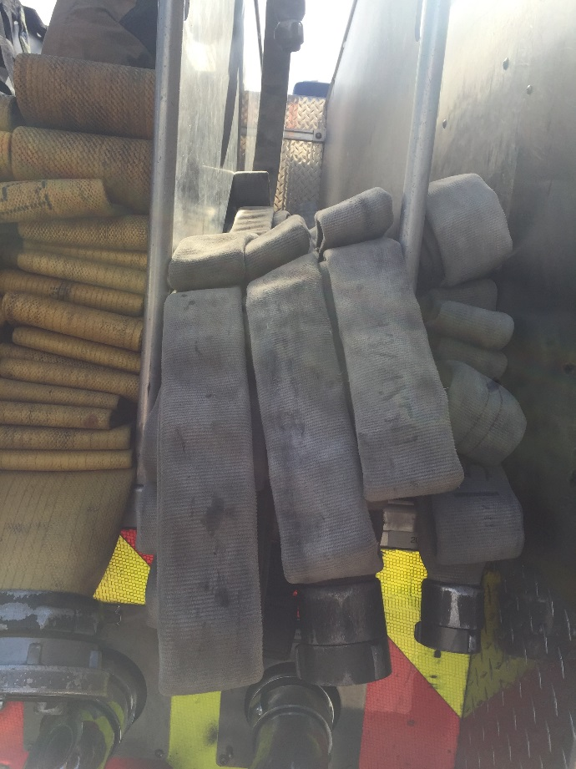
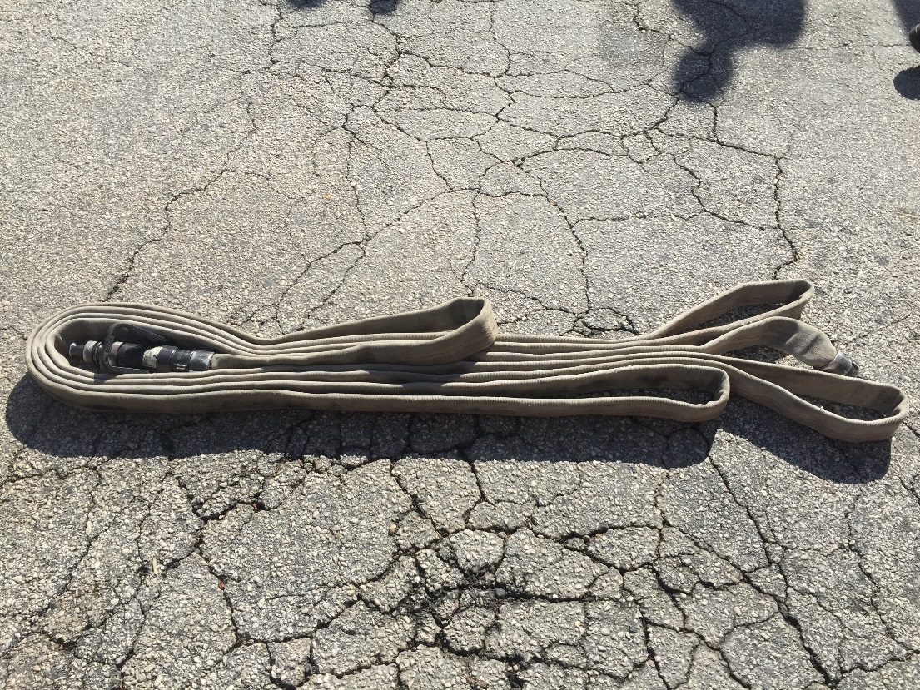

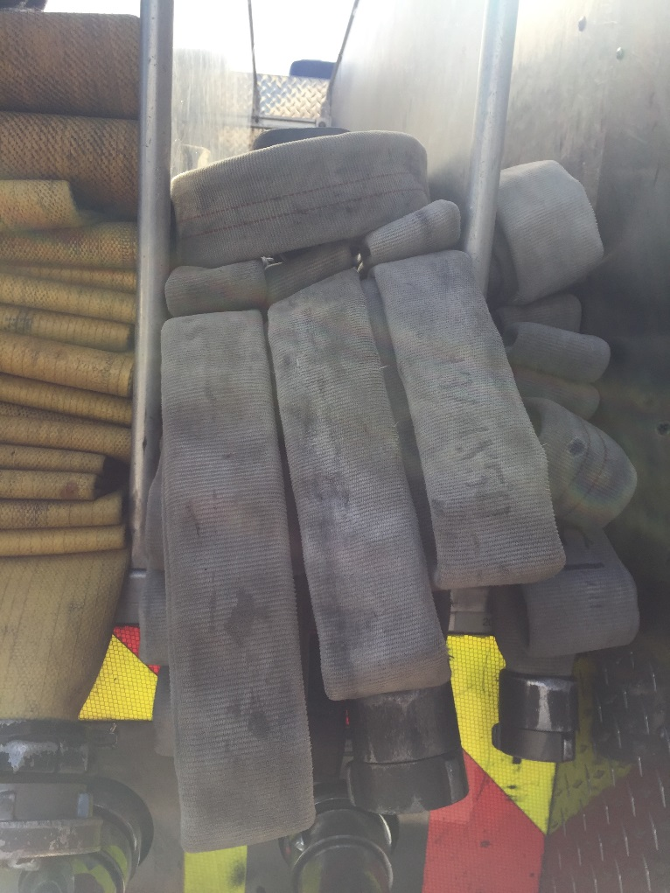
If it looks pretty, it’ll pull pretty!

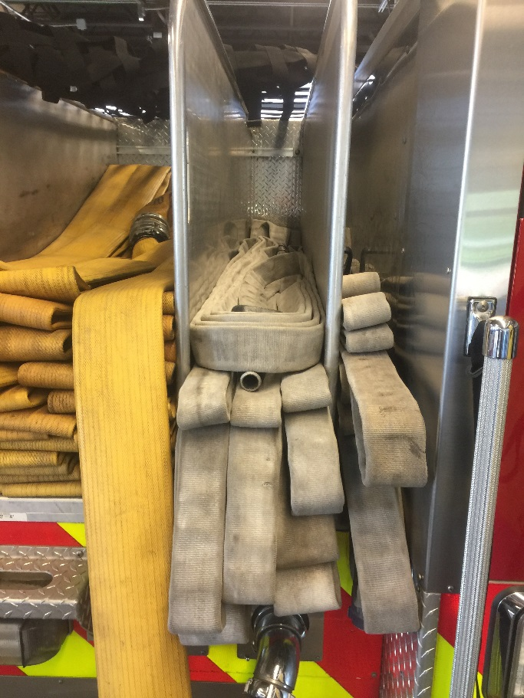

Pumping the Apartment – Horse Shoe Line:

NP – 50psi / 1” tip – 209gpm
1 ¾” – FL per 100’ = 60psi / FL per 50’ = 30psi
2 ½” – FL per 100’ = 8psi / FL per 50’ = 4psi

- 150’ of 1 ¾” = 140psi
- 150’ of 1 ¾” + 50’ of 2 ½” = 144psi
- 150’ of 1 ¾” + 100’ of 2 ½” = 148psi
- 150’ of 1 ¾” + 150’ of 2 ½” = 152psi
- 150’ of 1 ¾” + 200’ of 2 ½” = 156psi
- 150’ of 1 ¾” + 250’ of 2 ½” = 160psi
- 150’ of 1 ¾” + 300’ of 2 ½” = 164psi
If it looks pretty, it’ll pull pretty!

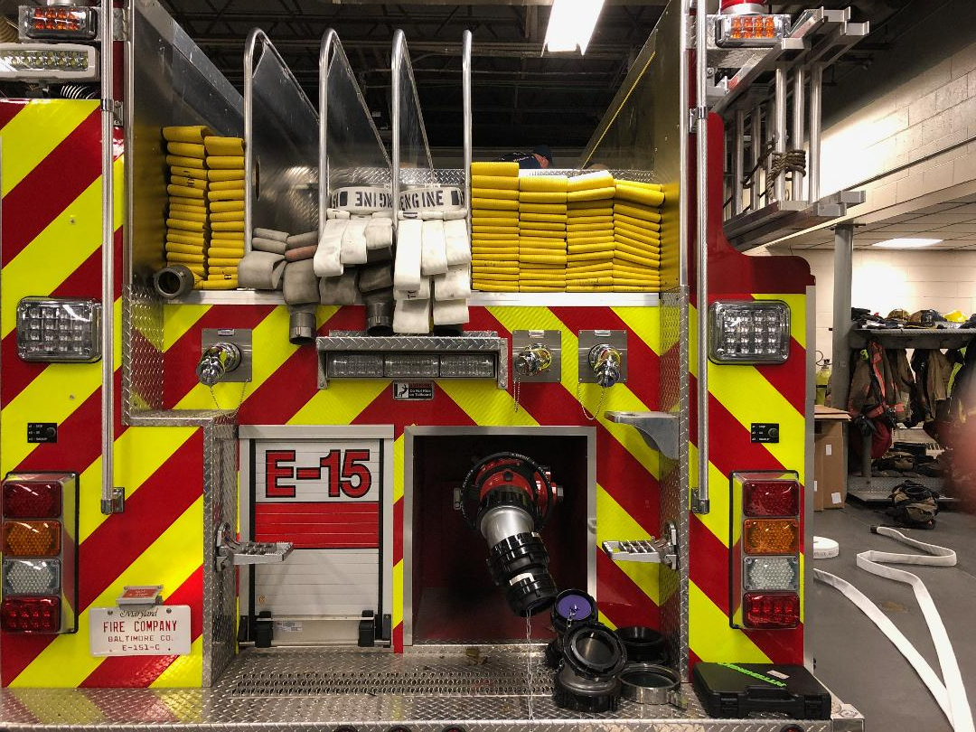

Pumping the Apartment – Horse Shoe Line:

NP – 50psi / 15/16” tip – 180gpm
1 ¾” – FL per 100’ = 50psi / FL per 50’ = 25psi
2 ½” – FL per 100’ = 6psi / FL per 50’ = 3psi

- 150’ of 1 ¾” = 125psi
- 150’ of 1 ¾” + 50’ of 2 ½” = 128psi
- 150’ of 1 ¾” + 100’ of 2 ½” = 131psi
- 150’ of 1 ¾” + 150’ of 2 ½” = 134psi
- 150’ of 1 ¾” + 200’ of 2 ½” = 137psi
- 150’ of 1 ¾” + 250’ of 2 ½” = 140psi
- 150’ of 1 ¾” + 300’ of 2 ½” = 143psi

2” Hose / Static Apartment Line 100’ of 2” 200’ of 2 ½“

2” Hose / Static Apartment Line
100’ of 2”
200’ of 2 ½”
1” tip – 210gpm
LENGTH | 100’ | 150’ | 200’ | 250’ | 300’
PSI | 72 | 76 | 80 | 84 | 88

2” Hose / Static Apartment Line
100’ of 2”
200’ of 2 ½”
1 1/8” tip – 265gpm
LENGTH | 100’ | 150’ | 200’ | 250’ | 300’
PSI | 82 | 89 | 96 | 103 | 110

2” Hose / Static Apartment Line
100’ of 2”
200’ of 2 ½”
1 ¼” tip – 326gpm
LENGTH | 100’ | 150’ | 200’ | 250’ | 300’
PSI | 95 | 105 | 116 | 126 | 137

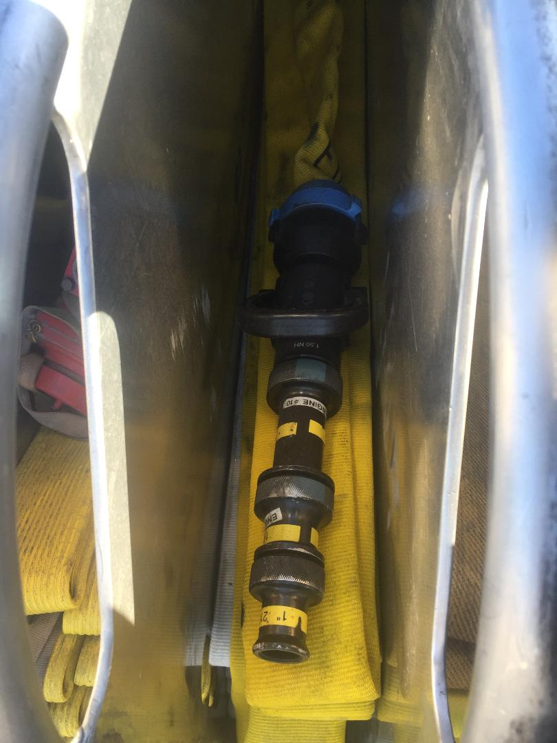
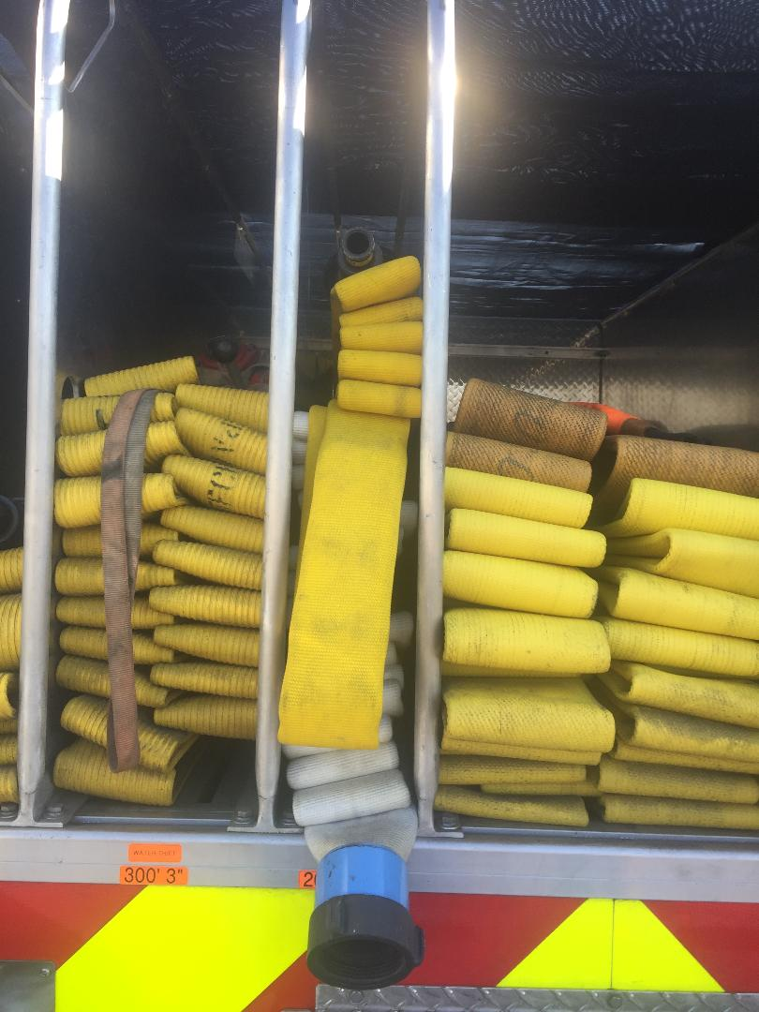

Ladder Pipe Operations

If you are the engine pumping a truck for ladder pipe operations, you need to have a dedicated water source. In Baltimore County we have two ways to perform Ladder Pipe Operations. The first method is a Pre-piped Aerial Ladder, and then the Second method is a Fly Pipe.
Considerations:
- Insight of the Truck
- In-Line of the Truck
- No further than 200’ from the Truck
- Engine Pressure (EP) no higher than 180psi

Pre-piped – Has (2) 4” storz connections on either side of the of the turn table. The pipping runs from the storz connection all the way to the tip of the aerial. At the tip of the aerial, you will find either a stacked tip or a constant flow master stream nozzle. The engine that is supplying the Ladder Truck will stretch a supply line from their LDH discharge to the Trucks LDH storz connection. Recommended hose used for this is 4” in Baltimore County.

Fly Pipe – Ladder Trucks that are not pre-piped, and have 100’ of 3 ½” hose. For this type operation, both drivers will be needed to set this up. The attachable nozzle will be set at the tip of the aerial, and then the 3 ½” hose will be connected. Both drivers will now work on placement for operations. A thief will be placed on the ground opposite side of where the water will be flowing, and the 3 ½” hose will be connected to the thief.
At this point the engine that’s supplying the ladder truck, will stretch a supply line from the engines LDH discharge to the thief.
As the driver of engine, you will need to figure out the Friction Loss (FL) from the engine to the Truck, based off what the Truck driver tells you to pump them. The Driver of the Truck is to determine what the Pump Operator needs to pump the Truck, but the Pump Operator needs to add the FL.

NEVER PUMP OVER 180psi Per BCoFD SOP’s

Knowing the difference:

Pre-Piped vs. Fly Pipe
Fly Pipe:

(Rule of Thumb) 70 / 70 / 70
70 Feet – 70 Degrees – 70psi

The operator of the Truck, should tell you what psi to pump them at.
- GPM?
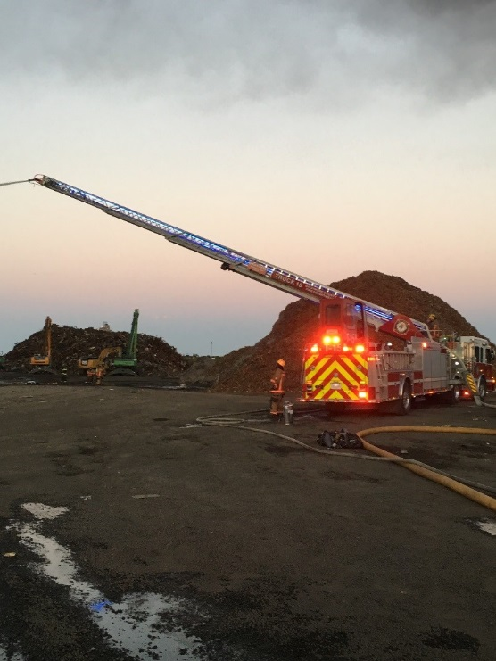
- Elevation?
- Size Line? (3 ½”)
Fly Pipe:
- Tip sizes
- 1 3/8 -
- 1 ½ - 559 GPM
- 1 ¾ - 761 GPM
- 2” – 994 GPM
- 100ft of 3 ½ inch hose

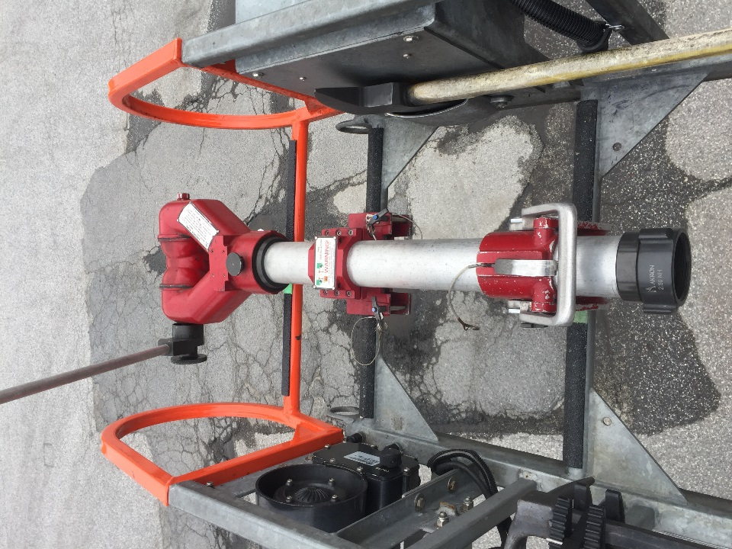
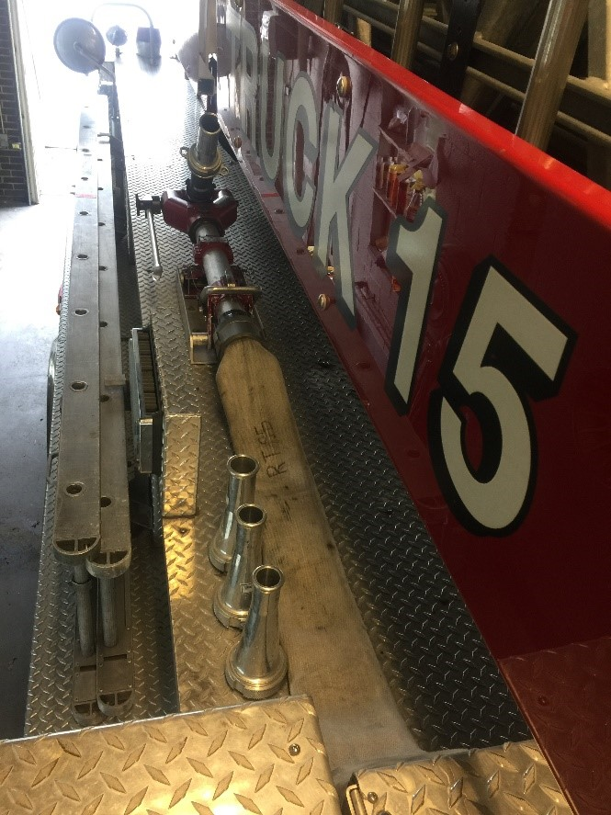

Pre-piped:
